

IBM® Tivoli® Software

Maximo extensions for Building Information Models

For Maximo 7.6.0.8

Technical contact: Doug Wood [doug.wood@us.ibm](mailto:doug.wood@us.ibm).com

Marketing Contact Kawon Park [[kpark@us.ibm.com](mailto:kpark@us.ibm.com)](mailto:kwoodbur@us.ibm.com)



The Maxim extensions for Building Information Modeling (BIM) is released as trial software and distributed on the IBM Service Management (ISM) Library. An existing Maximo Asset Management 7.5 or 7.6 license and installation is required. Trial software is not supported by the IBM Maximo support program; however, support is available directly from the IBM Maximo development team for as long as the software is available for download on the ISM Library. Check the ISM Library for the most recent version as well as continued availability. Only an English version is distributed during the trial. Your feedback is important because the software is being evaluated for possible integration with other Maximo products. Send all support questions and feedback to: [maxbim@ca.ibm.com](mailto:maxbim@ca.ibm.com)



**© Copyright International Business Machines Corporation 2011.**

US Government Users Restricted Rights – Use, duplication or disclosure restricted by GSA ADP Schedule Contract with IBM Corp.

Contents

List of Figures vi

1 Overview 4

1.1 Utilizing BIM models with Maximo 4

1.2 Supported Software 4

1.3 Features 4

1.4 Acquiring COBie Data 9

1.5 COBie data requirements and Quality 10

1.6 Field Mapping 13

1.7 Known Limitations 16

2 Import/Export Application 17

2.1 Location References 17

2.2 Classification 18

2.2.1 OmniClass Import 18

2.2.2 Classification, Specifications, and Attributes 21

2.2.3 Site level defaults 23

2.2.4 Classification and Sites and Organizations 23

2.2.5 Sample Classification Setup 23

2.3 Building Model Import/Export Application 24

2.3.1 Creating a new Project 24

2.3.2 Validate Sessions 31

2.3.3 Import Sessions 33

2.3.4 Update Session 34

2.3.5 Merge Sessions 36

2.3.6 Export Sessions 37

2.4 Merge with Existing Data 39

2.5 Import Filters 42

2.6 Custom Attribute Mapping 44

2.6.1 Map to Specification 45

2.6.2 Map to Field 46

2.6.3 Adding Attribute Maps to Projects 46

2.7 System Mapping 47

2.8 Advanced Options 48

2.8.1 Configure Model Data 48

2.8.2 Configure Maximo Data 56

2.9 Building commissioning 62

3 Product Application and other Extensions 64

3.1 The Product Application (ISM Only) 64

3.2 The Design Specification Application (ISM Only) 67

3.3 Other Extensions 67

3.3.1 Viewing Import information 67

3.3.2 Inspect Asset Details 68

3.3.3 Display System Details 69

3.3.4 Other Extensions 70

4 Security 70

4.1 BIM Specific Signature Options 70

4.2 Conditional UI 71

5 Trouble Shooting 73

5.1 Import 73

6 COBie to MAXIMO Field Mapping 74

6.1 Contact 74

6.1.1 As Person 74

6.1.2 As Company and Company Contact 75

6.2 Facility 76

6.3 Floor 77

6.4 Space 77

6.5 Component 78

6.6 Type 79

6.7 Zone 80

6.8 System 80

6.9 Job 81

6.10 Attributes 82

6.11 Document 83

6.12 Spare 83

6.13 Resource (Tool) 84

6.14 Assembly 84

7 Appendix REST API support 85

8 Appendix – Summary of Database updates 87

8.1 Tables Created: 87

8.2 Synonym Domains Added 88

8.3 Changes to existing tables 89

8.3.1 Locations 89

8.3.2 Asset 89

8.3.3 Jobplan 89

8.3.4 LocSystem 90

8.3.5 Person 90

8.4 CompContact 90

8.4.1 JobPlan 90

8.4.2 ASSETATTRIBUTE 90

8.4.3 COMPANIES 90

8.4.4 ITEM 90

8.4.5 INVVENDOR 90

8.5 Additions to Synonym Domains 90

List of Figures

Figure 1 – Model viewer embedded into the Maximo Locations application 8

Figure 2 - The Model viewer for work order dispatch 9

Figure 3 - OmniClass Import format 18

Figure 4 – OmniClass import utility 19

Figure 5 – OmniClass Import History 20

Figure 6 – Default Classifications 21

Figure 7: BIM Projects Application 24

Figure 8: BIM Project Sample 25

Figure 9: New session screen 27

Figure 10: Session Log 31

Figure 11 - Update Session Options 35

Figure 12 – COBie Export Session 38

Figure 13 - Import Filter 43

Figure 14 - Specification Map 45

Figure 15 - Field Map 46

Figure 16 – Upload dialog options tab – COBie File 49

Figure 17 - Import Attribute Mapping 55

Figure 18 – Upload dialog options tab – What to create 57

Figure 19 – Upload dialog options tab – Import Behavior 60

Figure 20 – Facility Commissioning tool 63

**Executive Summary**

The Maximo® Extensions for Building Information Models (BIM) provides support for integrating BIM data into, Maximo and for full 3D display of BIM data in context with Maximo applications and processes.

The data import and export implements a subset of the COBie standard

<http://www.wbdg.org/resources/cobie.php>

Feature include:

* Full COBie certification with support for 12 COBie tables and partial support for two additional tables
* Merge of multiple COBie data sets on import to support complex projects with multiple model files.
* Merge of imported data with existing Maximo configuration including: Attributes, classifications, units of measure, and other data to support integration of COBie data with enterprise data standards
* Merge of COBie data with previously imported COBie.
* Update of previously imported data with new COBie data to support multiple data drops over a project life-cycle
* Update non-COBie Maximo data with imported COBie data to support renovations and model created for existing buildings
* Export of COBie data to support interchanges with other COBie compliant operational systems.

In addition, there is a set of extensions to existing Maximo applications and new product and design specification applications to support the imported data.

The 3D viewer support provides out of the box support for the Autodesk Forge viewer In addition, there is an open API to support integration of viewer from other vendors. These viewers are directly integrated into the Maximo UI.

**Maximo Integration:**

* Automatic selection and display of the correct model
* Viewer context is synchronized to Maximo
* Maximo context is synchronized to the viewer
* The viewer may be used for asset selection
* Create work orders and service request from the viewer
* Display assets with open work order or service requests.
* Display Create and Edit Maximo systems

**Forge Viewer features:**

* Full 3D navigation
* Basic Search
* Model Properties
* Model Tree
* Sectioning of the model
* Model walk thru

For further discussion and participation please join our [forum](http://www.ibm.com/developerworks/forums/forum.jspa?forumID=2981) and subscribe to the following groups located at [Service Management Connect Community](https://www.ibm.com/developerworks/servicemanagement/).

* [Asset Management](https://www.ibm.com/developerworks/servicemanagement/am/index.html)
* [Real Estate and Facilities Management](https://www.ibm.com/developerworks/servicemanagement/rfm/index.html)

**Changes History**

**Version 7.6.0.8**

* Add REST service methods for control of COBie processes

**Version 1.2.2**

* Move all reference to NavisWorks to a separate document
* Move all references to the Forge viewer to a separate document
* Move the install chapter to a separate document
* Move the Viewer API to a separate document
* System Maps
* Update Attribute Maps
* Updated Attribute Type matching
* Conditional UI features

**Version 1.2.1**

* Reorganize import section to put most advanced options into separate sections
* More options for ID creation
* Improvements to Merge with Existing Data
* Viewer enhancements
* Drop Maximo 7.5.0.3 and 7.5.0.4 support
* Bug Fixes

**Version 1.2**

* Support for AutoDesk Large Model Viewer
* New options for record ID formatting
* Merge COBie data with pre-existing Maximo data
* Creation of Maximo asset assemblies via COBie Assembly table
* Bug Fixes

**Version 1.1**

* Support for Maximo 7.6
* Improved install
* Option to import assets without creating an operating location
* Bug fixes

**Version 1.0**

* Addition to import/export control properties
* Improvements to import filters
* Bug fixes

**Version 0.4**

* Design Specification Application
* Update of previously imported data
* Map a COBie attribute to any Maximo field
* Import filtering
* Maximo 7.5.0.4

**Version 0.31**

* Support for COBie extension columns
* Provisional support for MS SQLServer

There are no database changes from 0.30 to 0.31

**Version 0.3**

* Support for COBie Document and Job tables
* An option to import Contacts as Companies and Company Contacts
* Incremental import to allow new data to be added to a previous import
* Integration of the viewer into the Work order tracking application
* Building Commissioning (Bulk status change of imported data)
* COBie export
* Site level configuration of import and export options
* 3rd part viewer integration framework

# Overview

## Utilizing BIM models with Maximo

Building Information Models (BIM) is an industry representation of a building that is used during the design and build phases of building construction. This data model provides the information in its attributes to describe (in detail) the infrastructure of a building. This is becoming more frequently used by contractors and is part of the turnover of a building to the owner. This model provided at turnover is generally referred to as the “as built” state of the building.

Building owners who are commissioning a building into production need the information in this model to perform facilities management. The process of loading this information into your maintenance products (like Maximo) is costly, time consuming, and may introduce errors. The code contained in this package allows the automatic loading of the data in the BIM model into Maximo to begin the process of maintaining the building. This state is referred to by “as maintained”.

Once the data is imported, this package provides 3D visualization of the full building model in context with the imported data. This improves the efficiency of the maintenance work planning and execution process. Finally, the data, with any changes made during operations may be exported to update the model for a renovation project, or for use in other tools.

## Supported Software

The Maximo extensions for BIM is offered as trail software. Trial software is not supported by the IBM Maximo support program; however, support is available directly from the IBM Maximo development team for as long as the software is available for download on the ISM Library. Send all support questions and feedback to: [maxbim@ca.ibm.com](mailto:maxbim@ca.ibm.com)

**Maximo™**: Supported Maximo versions are 7.5.0.5 to 7.5.0.11. The COBie import capability is available in Maximo Feature Pack 7.6.0.6 as part of base Maximo, and there is a separate download to enable the Forge viewer in 7.6.0.6. Maximo7.6 users must upgrade to 7.6.0.6 for continued BIM support.

**The Forge viewer:** The Forge viewer is a cloud based viewer. To utilize it in Maximo a subscription from Autodesk is required. The Forge viewer requires a browser that supports WebGL. Tested browsers include: Micorsoft Edge. Internet Explorer 11, Firefox v42.0, Chrome v47.0.

## Features

#### COBie Import

The BIM Projects application loads BIM model data in COBie format into Maximo locations, assets, systems, persons, company, Job Plan, Master PM, PM, new Product table, and others. The import supports:

* COBie CVS and Excel data files. COBie tables supported are:
  + Facility
  + Floor
  + Space
  + Component
  + Type
  + System
  + Zone
  + Attribute
  + Contact
  + Document
  + Job
  + Spare
  + Resource (Tools only)
  + Assembly (For creation of Asset Assemblies)

The import supports merging, which allow new records to be added to previously imported COBie. On import, all import data is tested for a match against existing Maximo records and if a match is found, the record is skipped. This is fine grained so in addition to being able to add new primary records such as locations and assets, new attributes, and attachments can be added to existing records and new contacts can be added to existing companies. This provides for reuse of products, companies, and job plans across models.

If a component references a type that does not exist in the import data, the import attempts a name match against the product table to resolve the reference. This is intended to support using SPie (<http://www.nibs.org/?page=bsa_spie>) data to build a reusable product library.

#### COBie Validation

The COBie validation is a two stage process. The first stage validates the integrity of the COBie file or files independent of Maximo. The second stage test the model against Maximo for issues such as missing measurement units, missing classifications and some field length constraints.

#### COBie Update

Subsequent imports of COBie data can update in an intelligent fashion records originally created via an import. Or a first time update may associate COBie records with existing non-COBie Maximo data. Update may be restricted to only fields without Values set. For Maximo records that carry a change date, the update process can filter for only COBie data that is more recent that the Maximo change date or all data can be updated.

#### COBie Export

A facility that was originally created via a COBie import or updated to link with COBie data can be exported to COBie including any additions or changes to the imported data.

#### Filtering

Imports and updates may have filters applied. The filters work by pattern match against the COBie name field and are complimentary to the export filtering provided by the COBie Revit toolkit.

#### Attribute Maps

Imports and Export may define mappings between COBie attributes (by attribute name) and Maximo tables and fields. On import, a mapped attribute is stored in the Maximo attribute type or Mbo field defined in the mapping, and on export, any mapped Maximo attribute type or field has its value exported to the named COBie attribute. This is particularly useful for Maximo installations that have added custom fields.

#### OmniClass or other classification import

The OmniClass tables in .CSV format or the .xls format published on the OmniClass website:

<http://www.omniclass.org/tables.asp>

can be imported as Maximo classifications. Or any user defined classification scheme that is represented in the OmniClass .xls format may be imported.

#### Building Commissioning

A mass status update tool that updates the status for all locations, assets, products, job plans and PMs referenced by a facility. Its primary function is to change the status of imported data from imported or draft to active.

#### Maximo Extensions

There are several extensions to the core Maximo applications to support the COBie data model. The largest of these is a new Product application that maps directly to the COBie type table.

Others include:

* Additional fields in the Location table for space descriptions
* Addition of a ModelId field to several table to support the COBie external identifier
* Classification of systems, person and company contacts
* An “Imported” status added to several applications

#### Product Application (ISM Offering only)

The extensions include a new Product application to manage product descriptions. The data model is based on the COBie Type table. It includes:

* Classification and specifications
* A list of Job Plans appropriate to the product. This is intended to document both manufactures’ recommended maintenance and owner developed maintenance procedures.
* Attachments
* A list of assets that are instances of the product, and a reference to product is added to asset.
* A link to the Company which manufactures the Product, and Companies now have a list of products they produce
* A parts manifests with a list of Companies that can supply the part and a link to Item Master
* A list of specifications satisfied by the Product.

#### Design Specification Application (ISM Offering only)

The extensions include a new Design Specification application to track requirements against locations. It is a view into the Product application which removes vendor and product specification fields. It includes:

* Classification and specifications
* Threaded comments for design review
* A list of locations to which the specification applies
* A list of products which meet the specification

#### Integrated 3D BIM viewer

The building model viewer provides visualization of Building Information Models (BIM) data in the context of the Maximo Assets, Locations, and work order tracking applications. In this context it provides the following features:

* Maximo Integration
  + Model file management - The viewer automatically displays the correct model file(s) for a selected Maximo location or asset. If there are multiple models available, a list is provided and most context is maintained when switching between models
  + Viewer context is synchronized to Maximo (Locations and assets)- Selecting a record in Maximo selects the corresponding item in the view and zooms and centers the view on that item.
  + Maximo context is synchronized to the viewer (Locations and assets) - Selecting an item in the viewer causes the corresponding record in Maximo to become the current Maximo record
  + The viewer may be used as an asset selection lookup anywhere in Maximo that an asset look-up menu appears.
  + The viewer may be used to select a set of assets to add to a work order or service request
  + Create work orders and service requests directly out of the viewer
  + Search the facility for open work orders, preventative maintenance work and service requests, display all or a selected set of the search results as the selection set in the viewer.
  + Display members of Maximo systems in the viewer - Search from systems and zones either defined for the facility, or for which the selected item is a member. Display all members of the system as the current selection or drill down to any member of the system and select it in the viewer.
  + Create and Edit Maximo systems from the viewer - The selection set in the viewer can be used to either create a new system or be added as a sub-tree to an existing system
  + Sequence through a multi-item selection set changing both the model view (zoom and center), and the current Maximo record to the current item in the set.
* Forge Viewer features exposed via the viewer toolbar
  + Full 3D navigation
  + Basic Search
  + Model Properties
  + Model Tree
  + Sectioning of the model
  + Model walk thru
  + Other standard viewer features

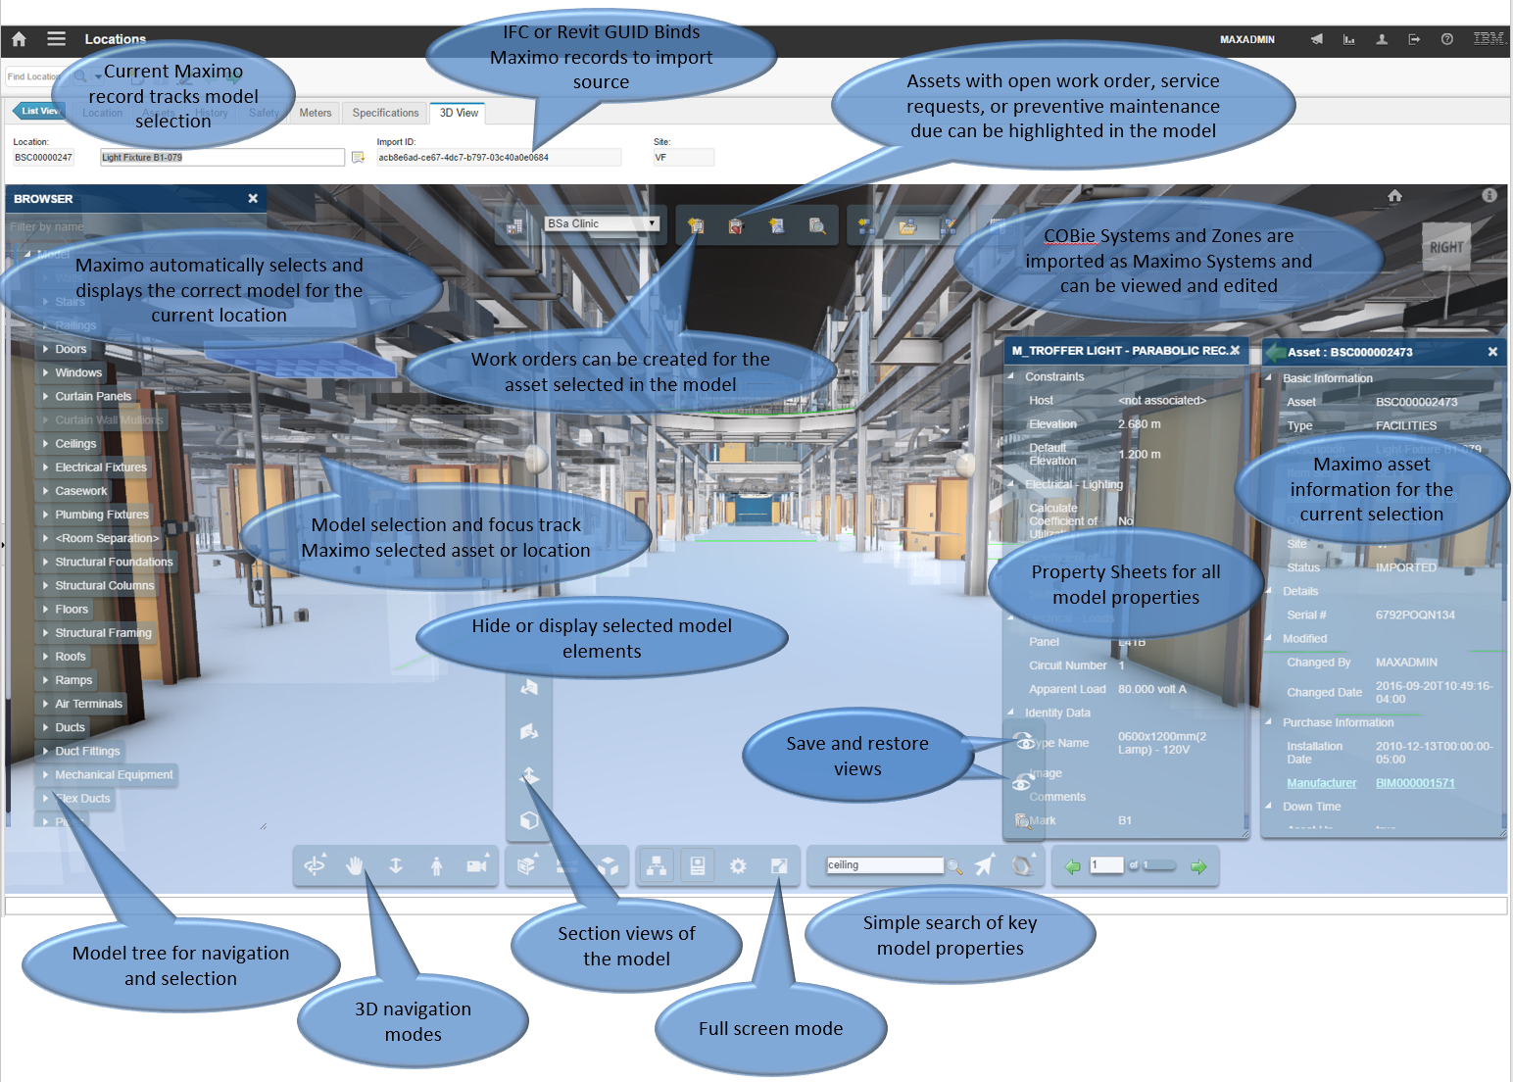

Figure – Model viewer embedded into the Maximo Locations application

In addition, the 3D model can be used in conjunction with the normal Maximo lookup mechanism to provide direct visual selection of assets from a building model.



Figure - The Model viewer for work order dispatch

## Acquiring COBie Data

The data import requires that the data to be imported be in the COBie format. Presented here are four methods to acquire COBie information for the required spreadsheet/comma separated values format. This is not an endorsement of any of these methods.

The first method uses the Revit COBie toolkit provided by Autodesk

<http://www.biminteroperabilitytools.com>

This is the most common method for Revit models

The second method integrates a third-party plugin from DCStrategies for Autodesk Revit 2011, 2013, and 2013. Visit the DCStrategies webpage (<http://www.dcstrategies.net/resources/cobie-toolkit>) and download the COBie toolkit. You will need to register before you can download.

1. Once downloaded, open the ZIP file and read the comprehensive PDF manual. Install the toolkit and use as instructed.

The third method uses a command line utility provided by AEC 3. *Note:* This method is recommended for users who only have an IFC/IFCXML file. Revit also has the option to export an IFC file, if the user prefers this method.

1. Visit the AEC 3 webpage (<http://www.aec3.com/en/6/6_04.htm>) and download the BimServices utility.
2. Once downloaded, open the ZIP file and install the program. Read the comprehensive PDF manual placed under …/aec3/bimservices and use as instructed.
3. Example: A user has the IFC file model.ifc and needs a COBie spreadsheet. Open a command prompt, navigate to the …/aec3/bimservices directory and input…

Transform1.exe _asCOBIE2.xml.xsl <file location>/model.ifc

…where <file location> is the directory that contains the file model.ifc. A COBie format XML spreadsheet file will be created in the same directory.

The fourth method use server based software from BIMServer.org. As its name suggest, it provides a building information model server on top of a database. It is an alternative tool to replace bimServices in creating COBie files from IFC models on realistically sized buildings. The advantage over bimServices is its integrated revision control, multiple user collaboration, and ability to query, merge and filter the BIM-model and generate IFC files on the fly. An Administrator manages users and projects, while users (with various privileges) may manage projects, such as adding revisions, checking in and out, and downloading files. In comparison with the Transform tool of bimServices, a user can upload an IFC file in the revision tab of a project and then download a COBie spreadsheet from the server. The conversion is done on request and the server provides multiple file formats.

While Documentation on BIMserver is sparse and incomplete, the application itself is fortunately easy to use and understand:

<http://www.bimserver.org/>

BimServer has been observed to require large amount of memory, on the order of 64GB RAM for large models. It should be run with a 64bit JVM and the JVM heap size set to an appropriate value. Some versions truncate tables at 64,000 rows. For realistic sized building, this is a problem for the attribute table.

The buildingSmartalliance (bSa) has provided some information on common COBie and IFC tools and practices:

<http://buildingsmartalliance.org/index.php/projects/commonbimfiles/>

#### Additional Resources:

* BimServices (<http://www.buildingsmartalliance.org/index.php/projects/ifccobie>)
* COBie (<http://www.wbdg.org/resources/cobie.php>)

## COBie data requirements and Quality

Many issues have been observed with the completeness and quality of COBie data generated from real BIM models. The import utility goes beyond the standard in several places in an attempt to provide the best possible import result. Following is a set of minimum requirements for the COBie data to be successfully utilized, and a set of best practices.

#### Minimum Requirements

The import enforces that the Facilities and Floor tables must be present. For the imported data to drive meaningful business processes, the Component table must also be present unless SPie format is being used to populate the product catalog.

**Model Id:** For the viewer to function the Maximo model ID field must be populated for all spaces and assets. The value in this field must uniquely identify the model element, and must map to a property visible in the files used in the viewer. This field is loaded from the COBie ExtIdentifier column. For a Revit model, it should be the Revit GUID, for and IFC model, it should be the IFC GUID

**Unique Names:** Each COBie table uses one or more column for a unique ID, basically a database key. For tables such as spaces that are referenced by other tables, this key must be unique. This may appear obvious, but the values in the key column(s) are generated from properties in the design tools, and the tools don’t enforce uniqueness. This is particularly problematic with space names which may be human entered. A space naming scheme may only guarantee uniqueness by floor especially for service spaces, whereas COBie requires uniqueness by facility. The COBie validate feature tests for duplicate names.

#### Best Practices

**Spaces:** The COBie specification effectively requires all components to reference a space by making no provision for any other reference. This is problematic for two reasons:

* The model for most large projects is divided into several linked files. Both Rooms and Spaces can map to COBie spaces. Rooms typically appear in the architectural model, and Spaces in the primary MEP model. Sub-discipline models may not have spaces. Coordinating Rooms and Spaces across models requires a well thought out strategy.
* Space definitions are often not created for service spaces such as plenums, elevator shafts and the like. Many components exist in these areas and may not have a logical associate to a defined space.

There are several strategies that can be used to address this. These include:

* Rigorously define all spaces such that there is a space definition for every volume in the model including external service areas
* Copy space definitions into linked models. This makes the spaces available in those models. COBie uses the space name to resolve component references. Even though the copied space has a different internal identifier in each model, COBie collapses all spaces with the same name into a single element. The Import utility will also do this even if the spaces are in different files assuming all the files are loaded in the same import session.
* Allow components to default to floor or facility references. The import provides several methods not covered in the COBie specification to address missing space reference. These include:
  + If no space is found to match the space reference in a component, the floor table is searched for a matching reference. This allows components to explicitly reference floors instead of spaces
  + Most models require every item in the model to be associated with a floor and to carry that reference in an attribute. If the attribute is exported to the COBie attribute table, the import can use it to establish a floor reference.
  + Failing both of the above, the import associates components with the facility

It is expected that most models will use a combination of these approaches.

**COBie Spaces and the Revit COBie toolkit:** .The Revit COBie toolkit supports both Revit Room objects typically used in Architectural models and Revit Space object typically used in MEP models. The toolkit allows the user to select by Revit family where object should be associated with spaces or rooms. On export, to prevent name clashes, the toolkit provides an option for _ARC to be appended to Rooms, and _MEP to be appended to spaces.

This approach doesn’t product the best data for facilities management. Typically, there are both rooms and spaces created for volumes that from an FM viewpoint are the same. The Room is inner wall surface to bottom of celling and the space is wall centerline to bottom of the next floor. The ideal solution is for Maximo is for the Room and the Space object to be represented by a single Maximo location and for assets contained in either to reference that location.

To support linked Models, the Maximo COBie import supports merging multiple COBie files during import. If COBie objects with the same name from the same table but in different files are found during import, they are merged into a single object with the first object encountered taking precedence. This supports the merging of Revit rooms and spaces.

It is recommended that:

* Only rooms are used in the Architectural model
* Only spaces are used in the MEP model.
* Rooms and spaces that describe essentially the same volume have identical names
* The COBie toolkit option to append _ARCH and MEP is not used
* Do not use the Toolkit option to append data from linked model into a single large COBie file. Create individual files for each model and allow Maximo to merge them on import.
* That all COBie files from a linked model be imported together
* That the Architecture model appear first in the list giving preference to Rooms as the primary object

If both Rooms and spaces are used in the same model and have the same name, they are kept distinct and a Maximo location object is created for each. However all component references are associated with the first object encountered.

**Systems:** Not all COBie export tools generate COBie systems from models systems. However, in Revit models the System Name attribute has been observed to contain system membership and to be in wide use. The import utility can process this attribute to generate system definitions as part of the import. Therefore, where available, this attribute should be included in the COBie data.

**Categorization:** COBie support Categorization of most objects. It can be useful in search and in driving automated workflows. However, to be useful, it must be consistent across the entire building portfolio. There are several competing standards for categorization of building elements, and even within a single standard, there is inconsistency across versions. It is recommended that the owner adopt a single unified classification scheme and require use of this scheme in all contracts.

It has been observed that categorization is often not exported from the model to COBie. The import utility can use the OmniClass Number attribute or a user defined attribute to assign categories when they are missing. When available, this attribute should be included in the COBie data.

**Attributes:** Most models include a large number of attributes most of which are irrelevant to facilities management. Ideally the model would tag the attributes that should be propagated to Maximo either via a family designation or some easily searchable naming convention. Failing that, all attributes except those describe in this section can be eliminated from components. On the other hand, every effort should be made to include as much specification and performance information as possible on the type definitions.

**Spare Part:** The COBie specification is unclear if the Spares table represents a manifest of the Field Replaceable Units (FRUs) for the product, essentially an exploded parts list, or actual inventory of spares. This application treats it as the former.

**File size:** Many of the COBie conversion tools have restriction on the size model they can handle. It is possible to break an IFC file into several smaller files and generate COBie data from each. The import utility will accept multiple files for input and reassemble them. This technique can also be used when the model consists of several linked files. From Revit, this can be done by using the IFC Import/Export configure to select a subset of families for export

**Large Buildings:** There are many issues with handling large buildings. COBie does not support the concept of a wing or section so it is not possible to directly segment large buildings within a single COBie file. However, there are many ways to break a project into several COBie file and reassemble them. Most large projects segment the model files. We recommend carrying the segmentation through to the COBie file and import.

## Field Mapping

The import uses the following field mapping between COBie tables and Maximo tables:

|  |  |
| --- | --- |
| COBie to Maximo Mapping | |
| **COBie** | **Maximo Import location** |
| Facility | Location and COBie import project |
| Floor | Location |
| Space | Location |
| Component | Location and Asset, PM |
| System | System (Category configurable) |
| Zone | System (Category configurable) |
| Type | Product or Design Specification (New for COBie support) ), Item. Many fields can be copied to each asset referencing the Type |
| Attribute | Specifications for: Location, Asset, Product, Job Plan, Item |
| Contact | Person, Company, Company Contact, InvVendor |
| Document | Attachments |
| Jobs | Job Plans, Product Job (New), MasterPM, |
| Spare | Parts tab of Product (New) |
| Resource (Tools) | ItemTool |
| Assembly | Asset – Sets the asset parent field. |

#### Facility

The COBie Facility table is expected to contain a single facility. It is mapped to a Maximo locations table. The parent location of the facility is specified on import

#### Floor

The COBie Floor table is mapped to the Maximo Locations table. Each floor is a child of the facility.

#### Space

The COBie Space table is mapped to the Maximo locations table. A space is the child of a floor if it has a valid reference, if not; it is a child of the facility.

#### Component

The COBie component table is mapped to both the Maximo Asset table and the Locations table[1]. A location is created for every component. The location is a child of a space, floor, or the facility based on the best valid reference. The component’s reference to a Type is resolved as a reference to a Product.

Note: Maximo does not allow a location or asset to have two parents. If a Component references multiple spaces the first reference is used.

If the “Use Operating Locations” option is not selected on import, then locations are not created for assets.

If the component references a Type, and one or more Jobs of type PM also reference the Type, then a Preventive Maintenance (PM) record is created for each of the Jobs

#### System

The COBie System table is mapped to Maximo systems. For each system defined in COBie a Maximo system is created. The system is hierarchical with the root being the Facility location and the locations created for each Component that is a member of the systems, children of the Facility location. Systems cannot be created if operating locations are not used.

#### Zone

The COBie Zone table is mapped to Maximo systems. For each zone defined in COBie a Maximo system is created. The system is hierarchical with the root being the Facility location and the locations for the Spaces that are members of the zone as children of the facility.

#### Type

The COBie Type table maps to the Maximo Product and optionally, the Item Master table. The Product table is added by this package. A Product and optionally an item master are created for each type. The Product application includes a list of all Assets that reference the type and a list of all Jobs that reference the type.

There is an import option that allows COBie type to be imported as design specifications instead of products. Specifications are associated with the operating location created for a component instead of the asset. That way if the asset is replaced, the specification is retained. This option is typically used to import a design model. If the Revit GUID is maintained when the specification is updated to the selected product, then an update links the product to the specification. This option is not available if operating locations are not used.

Attributes and Documents that reference a Type can be duplicated to every asset that is created from a Component that references the Type.

#### Contacts

The COBie Contacts table maps to the Maximo Person table either/or/and the Maximo Company and Company Contact tables, depending on import options. Be default if a contact is used in a Created By context a Person record is created for that contact. If a contact is used as a manufacturer, warrantee guarantor or similar, a Company and a Company contact is created. If two contacts list the same company, the company is reused.

#### Job

The COBie Job tab is mapped to the Maximo Job Plan table. If the Job is of type “Preventive Maintenance” a Master PM entry is also created.

#### Spare

The COBie Spare tab is mapped to the Maximo BIMProductParts table which is related to the Product table. Only parts that are reference by a product are imported.

#### Resource

Only resource of type Tools are imported. These are mapped to the Maximo ItemTool table.

#### Document

The COBie Document tab is mapped to Maximo attachments as follows:

* Facility: Floor: Space: Documents are attached to the location
* Component: Documents are attached to the Asset
* Type: Documents are attached to the Product and to the related Item Master, or to Design Specification, and may also be attached to assets reference the Type.
* Job: Documents are attached the Job Plan

#### Attributes

The COBie Attribute tab is mapped to Maximo specifications (Attributes) and Attribute Types. Attributes are analyzed to find groupings with the same name and data type and a Maximo Attribute Type is created for each grouping. Attribute values appear on the Specifications tab of referenced objects as follows:

* Facility, Floor, Space: Locations table
* Components: The Asset, the related location or both
* Type: Product with an option to also copy them to the related Item Master, and to copy them to every asset that references the type, or Design Specification
* Jobs: Job Plans table
* Others are not currently supported

For attributes to be associated with a Maximo object, the object must be classified either through the COBie Category field or through the import default configuration. If attributes are copied to multiple locations, they are not linked and any updates are independent.

#### Assembly

The Assembly table can be used to create Maximo asset assemblies. Only Component assemblies are supported not Type Assemblies, and the assembly must be categorized as “Fixed” or “Include”. For each Component that appears as a child in an assembly, the asset Parent filed is set to the root of the component. The assembly name is not used. Although COBie assemblies only define a single layer, multiple assemblies can be combined to build a complicated Asset assembly tree in Maximo.

#### COBie Extension Columns

The COBie specification allows additional user defined columns to be added to any table. These columns may be converted to attributes on the first step of the import and treated exactly like attributes for all further processing.

#### Specific field mappings:

**Category:** The category field maps to Maximo classifications. A classification with a name that matches the category must exist in Maximo at the time of import. If it does not either it is created if the “Create Classifications” import option is selected, or a default is use if one is provided in the import, otherwise the object is not classified. If a list of categories is supplied, the first match is used.

**ExtIdentifier:** A ModelId is added to the Locations, Assets, System, and Product tables. The ExtIdentifier is placed into this field. It is used for matching on subsequent imports, and by the viewer.

**Measurement units:** Maximo requires that all measurement units exist in the Units of Measure table. The import provides an option to automatically add them. If they are not added and don’t exist, the field is left blank

**Date Fields:** All date fields must be valid dates. The import attempts to convert the strings into internal date representations. If this fails, the fields are left blank.

#### Custom Field Mapping

Custom mappings between any COBie attribute and most Maximo fields may be defined for both import and export.

## Known Limitations

* The import has been observed to use excessive memory and generate out of Memory errors on the server. (WebSphere, 1GB Heap size, no other active processes)

To increase the WebSphere heap size:

From the WebSphere Administrator Console:

1. Select **Server > Application Servers** and select the <ServerName>
2. In the **Configuration** tab, navigate to **Server Infrastructure > Java and Process Management > Process Definition > Additional Properties: Java Virtual Machine**.
3. Edit the field Maximum Heap Size. If the default is not specified, then it assumes 256.

* The .xls support requires a large memory footprint. Use .CSV file to reduce memory requirements
* If Auto numbering is not enabled for Item and any items are created manually that conflict with the Product auto-numbering scheme, a database error will prevent the creation of items associated with products created by the import.
* When the BIM extensions are installed on a non-English system, Maximo may fail to start after the installation with an invalidSiteOrgType exception. This is a known Maximo issue. To resolve run TDToolkit.bat -pmpupdatecalibration –langja from <Maximo install dir>/tools/maximo.

# Import/Export Application

The building model import/export application provides import into and export from Maximo of a subset of the data defined by the COBie interchange standard.

<http://www.wbdg.org/resources/cobie.php>

The following COBie tables are supported

* Facility
* Floor
* Space
* Component
* System
* Zone
* Attribute
* Types
* Contacts
* Document
* Job
* Spare
* Resource (Tools)
* Assembly (Limited to specific types of Component Assemblies)

In addition, it provides import of the OmniClass classification structure into Maximo classifications. Or any user defined classification scheme that is presented in the OmniClass file structure.

## Location References

COBie defines a three level location hierarchy for facilities. These are:

* Facility
* Floor
* Space

Components reference spaces. However, the standard provides no validation that the references at any level are present or valid. Maximo rigidly enforces that all locations must have a valid parent.

## Classification

It is desirable to classify various elements of the building model. Classification provides useful information about the role and function of an item. COBie supports classification through the Category field. The Category field maps to Maximo classification. A classification must exist that matches the category value for an item to be classified. Maximo requires an item to be classified in order to have attributes associated with it. A mechanism is provided to assign default classifications for each type of imported object. In addition, there is an option to automatically create classifications that appear in the COBie import but are missing from Maximo.

### OmniClass Import

OmniClass is a widely used classification scheme. Information about OmniClass can be found at:

<http://www.omniclass.org/>

The Maximo extensions for BIM provide for import of the OmniClass tables that are distributed in spreadsheet format. The import utility uses the 2nd (hierarchical tab) of the spread sheet in CSV format for import or the entire spreadsheet as an.xls or .xlsx file. It can also import any other set of classification in a similar format. It can import OmniClass in a flat file format with one number per line with the entries in parent child order. It uses the OmniClass number structure to build the hierarchy.

The required format is:

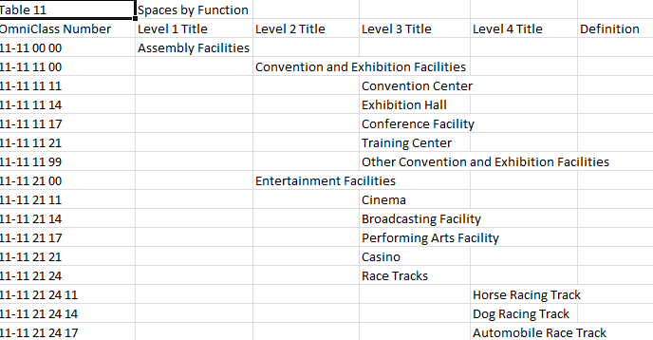

Figure - OmniClass Import format

Where there may be up to 7 levels of title.

To launch the OmniClass import Utility select Go To->Asset->Building Model Import

From the Select Action menu select OmniClass Import

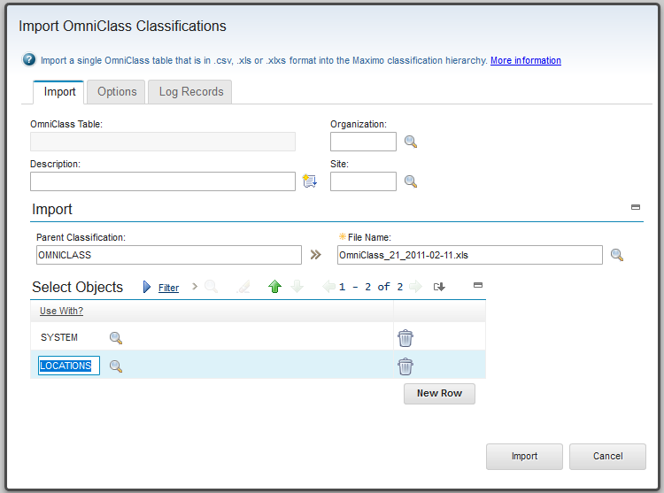

Figure – OmniClass import utility

**OmniClass** Table: Fillled in by the import from the table title specified in the import file.

**Description**: Descriptive data associated with the import. It is not propagated to any of the classifications created by the import.

**Organization**: If specified, classifications are created at the origination level. It defaults to the current origination, but may be cleared. It should be clear if a system level or item set level object is included in the Use With list.

**Site**: If specified, classifications are created at the site level.

**Parent**: The parent classification for the root of the imported classification tree. If this is blank, the OmniClass table name is created as a top level Maximo classification. Some care must be taken in selecting the parent classification so that it is appropriate for the intended Use With list. If there is a system or itemset level object in the Use With list such as Person or Item, then the parent classification should not have a value of organization. If an organization level object such as Company appears in the Use With list, then the parent classification should not have a value set for site. If the Organization or site fields are set for the import, then these values for the parent must either match or be blank

**Use With**: This specifies a list of Maximo objects for which the classifications created by the import are valid. If parent is not blank, all ancestors have the Use With list added to their list of valid objects. Normally Maximo propagates the valid objects for a parent classification to its children, however the import utility filters this so the classification created by the import have exactly the set of object specified on the import dialog. Some typical Use With values are:

* Table 11 -> LOCATIONS
* Table 13 -> LOCATIONS
* Table 21 -> SYSTEMS and LOCATIONS to support system maps
* Table 23 -> ASSET, PRODUCT, DESIGN SPECIFICATION, ITEM
* Table 34 -> PERSON, COMPANY CONTACT

**Generate Description:** IF this box is selected, the corresponding option is selected in each classification created. This should be used with care as it causes any description provided by COBie to be overwritten by the classification description. IN many cases, the COBie name field is stored in the Maximo description.

**Import**: Pressing the import starts the import and switches the dialog to the Log Record tab.( See Figure 10: Session Log). The import runs in the background. The dialog or the browser may be closed without interfering with the import process.

#### Classification Import History

There is a history of all import sessions. This may also be used to view the status of active import sessions.

To view the OmniClass import History select Goto->Asset->Building Model Import

From the Select Action menu select Classification Import History

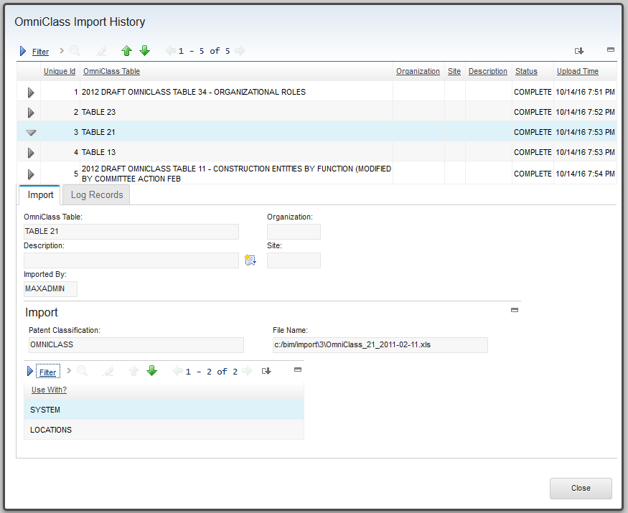

Figure – OmniClass Import History

### Classification, Specifications, and Attributes

Maximo allows additional name-value data pairs to be associated with locations, assets, Products, Items, Job Plans, and some other record types not related to the import. This additional data is referred to as specifications. However, there are two restrictions placed upon this data:

* Any Maximo record that is to have specification data must first be classified
* Any specification data must have an attribute type defined for it.

The COBie attribute tab is mapped to Maximo specifications. To meet the requirement that records must be classified; the Import application provides a site level configuration for default classification of imported records. This is defined for the import project so objects such as product that are org level objects still use the site level defaults for the project.

To define default classifications for a site: from the main tab of the import applications:

Select Action->Configuration Import Data->Configure Maximo Data

The import configuration is displayed for the site of the import project.

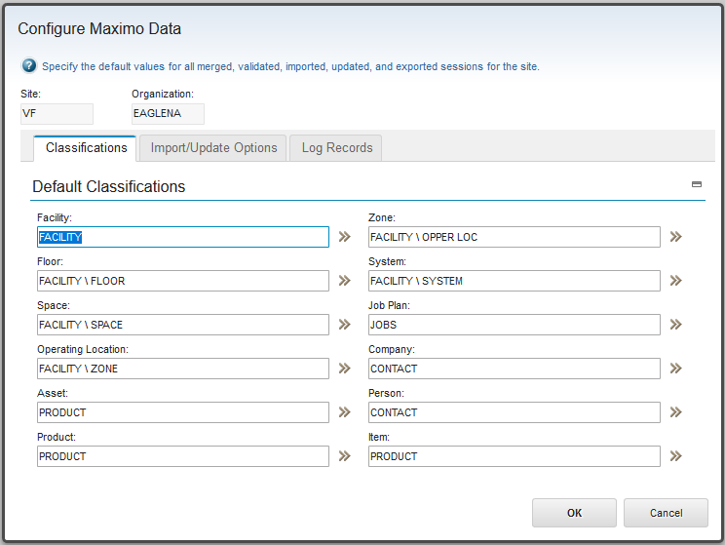

Figure – Default Classifications

**Site:** This is the site the defaults apply to. It is set from the site for the current project. This field is read-only. To configure defaults for a different site, create a project for that site then display the configuration dialog.

**Organization:** This is the organization for the site. This field is read-only

Classifications must be defined in advance and have the correct “Use-with Object” defined. Note: If the “Generate Description” option is selected for a classification, records that receive that classification will have any imported description replaced with the generated classification description.

The required “Use With” values are:

|  |  |
| --- | --- |
| **Use With** | |
| ***COBie Object*** | ***Maximo Object*** |
| **Facility, Floor, Space** | Locations |
| **System, Zone** | System |
| **Component** | Asset, Location |
| **Type** | Design Specification, Product, Item, Asset |
| **Contact** | Person, Company Contact |
| **Job** | Job Plans |

Some of the above Use With may vary depending on import options for where attributes are created. The above supports any set of options. The default classification for Product is also used for Design Specifications.

Some care must be taken with the classification specified for Job Plans. The level for the classification: System, Origination: or site determined by what values are provide when the classification is created must be the same or broader than the level at which Job Plans are created.

The import automatically creates the required attribute type definitions. It uses the following algorithm:

* All attributes from the import session with the same name are assumed to be the same type
* All fields with any variation of the string n/a are treated as blank
* The data type of the attribute type definitions is initially numeric.
* The value of each attribute is examined to determine if there is any non-numeric data. As soon as non-numeric data is encountered, the attribute type is changed to alphanumeric.
* For each attribute type discovered in the import data, the list of existing Maximo attributes with no organization or an organization that is the same as the import project, and with no site, and with the same site as the import project is searched for an attribute type definition with a description that matches the COBie attribute name, and the same data type.
* If a match is found, that type definition is used
* If no match is found, a new attribute type definition is created either at the system level, origination level, or the site level depending on the value of the “Attribute Creation Level” option.
* Attribute types are created in Maximo with one of:
  + Auto-generated sequence numbers managed by the import utility from the project for their name, and
  + The COBie attribute name as the ID if it fits with in the field, otherwise as sequence number as above
  + The COBie attribute name as the ID truncated to fit if necessary.

The COBie attribute name is used for their description.

### Site level defaults

Site level defaults may be set for many of the import options. Options set in The Configure Maximo Date, and the Configure Model Data dialogs are copied to each new import session and may then be altered. See the import session for a description of the options.

### Classification and Sites and Organizations

Maximo has a 3 tier hierarchy for isolating data and for applying security. It is:

System, Organization, Site.

Classifications can be created at any of these levels. It is a system level if both site and organization are blank, an organization level if organization but not site is specified and a site level if both are specified.

The import requires that classifications must be compatible with the level of the object that they will be used with. For example, Person is a system level object, therefor only classifications that have organization and site as null are matched to a category specified by a contact being imported as a person. This means that OmniClass import and defaults must be created at the correct level. Some import options can change the level at which objects are created. The following table shows the level required for a standard import. it is recommended to import all OmniClass tables at the system level.

|  |  |  |
| --- | --- | --- |
| **Table** | **Type** | **Minimum Classification level** |
| **Location** | Site | Site |
| **Asset** | Site | Site |
| **Design Specification** | Organization | Organization |
| **Product** | Organization | Organization |
| **Item** | Item set | System |
| **Person** | System | System |
| **Company Contact** | Organization | Organization |
| **Job Plan** | System, Site or Organization | Organization by default, but may be Site |

### Sample Classification Setup

The following set of base classifications has been found to work well with our test data

**Name Use WIth**

* OmniClass None, added by import as necessary
* Facility Location, System
  + Floor Location
  + Space Location
  + Bldg Operating Location
  + System System
  + Zone System
* Product Asset, Item, Product, Design Specification
* Contacts Person, Company Contact
* Jobs Job Plan

Notes:

* 1. The Use with for Contacts is impacted by the contact treatment import option. If either person or company contacts are not created, then the Use With is unnecessary
  2. If no attribute data is provided for Jobs, it may be desirable to leave the default blank and manually classify Job Plans after the import. The COBie category is stored in the Job Plan listing for the related Product.
  3. The Screen capture above show how this is used for the default configuration and how the OmniClass import is configured.

## Building Model Import/Export Application

The Building Model Import/Export application is located on Assets menu. (Go To->Asset->Building Model Import/Export). This displays the List page of the Import application.

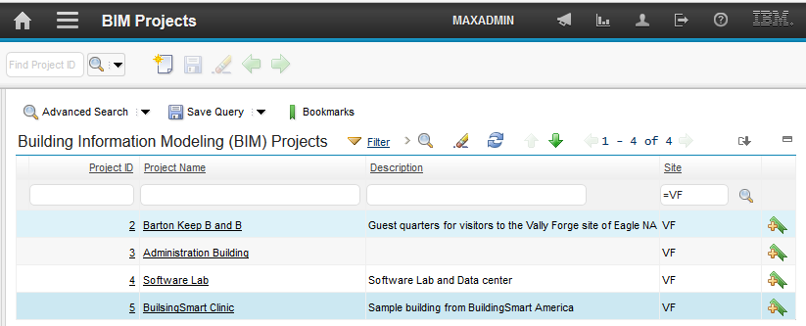

Figure : BIM Projects Application

### Creating a new Project

Each facility is associated with an BIM Project. The project groups interactions with the facility or models for the facility. Each interaction is called a session. A project may have session for multiple COBie facilities. All share the parent location defined for the project. This may be a useful way of breaking a large project into sub-projects such as wings. There are 5 session types:

* Validate: Validates the COBie file structure and how the COBIe file interacts with existing Maximo data. Validate makes no changes to the Maximo database.
* Import: Import new COBie data when the is no existing data for the Facility in Maximo, or Incrementally adds additional COBie data to previously imported data
* Merge. Overlays COBie data onto existing Maximo data for the facility in the COBie file. A Merge session may only be run once.
* Update: Updates date created by a previous import
* Export: Experts to a COBie spreadsheet the current state of previously imported data.

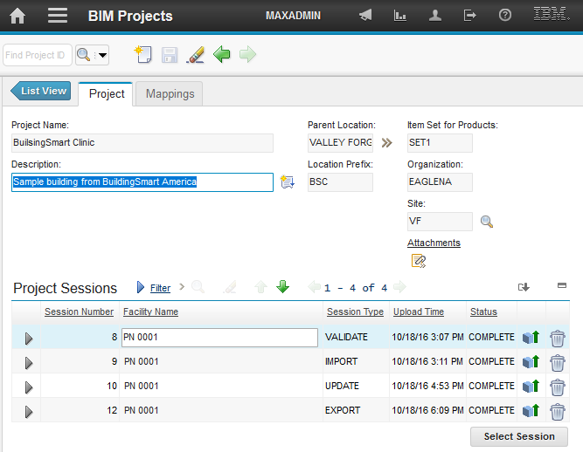

Figure : BIM Project Sample

The following must be specified:

* **Project Name:** A unique name to identify the project in the scope of the site
* **Parent Location** – The parent in the location hierarchy for the location created for the facility. This location must exist, must be an Operating location, and must be a member of the primary system for the site.
* **Location Prefix** – The import may automatically generate.sequence number for the value of the location, assetnum, systemid and other key fields[2]. The Location prefix is appended to the left of the sequence number of all site level objects. And the sequence number is left zero padded to fill the size of the smallest of the above fields. Each project must supply a unique location prefix[3].
* **Site:** The site id that will be used for all site level objects created by the import. This may be different than the default insert site.
* **Organization**: The Organization used for the import. It is derived from the selected site and is read-only.
* **Item Set for Product**: This field is read-only. It displays the itemset that is used for item level objects created by the imports. Its value is the default item set for the organization the selected site belongs to.
* **Attachments**: Allow documents to be attached to the project, it is also used by the export.

A description for the project may be provided.

The project stores the site, organization, and item set and uses these for all Maximo object created by the import. These values override the default insert site for the user. This prevents inconsistent data if a use changes their defaults while an import is in progress.

The next step is to create a session. The import supports multiple sessions and multiple session types. To create a new session, click the “Select Session” button. A choice of session types is provided. The options reflect the current state of the project. The possible choices are validate, merge import, update, and export. At least one import or merge must have completed successfully for the update and export options to be displayed.

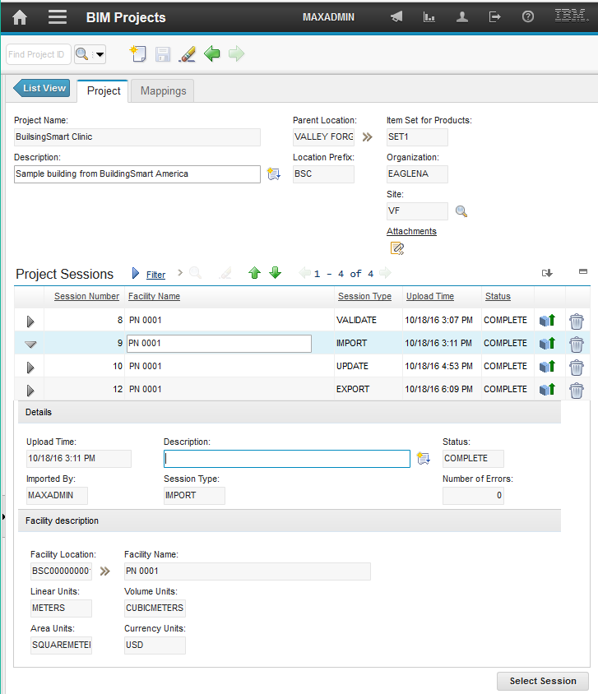

Figure : New session screen

Most of the session data is read-only and populated from the COBie facility definition.

#### Document Import

When a project is saved, a document import directory is created under the directory specified in the system property:

bim.import.docdir

This directory must be available for user file upload through some method such as FTP or a Windows share.

Each site is a subdirectory, and each project is then a subdirectory of its site. This directory is used for importing documents specified on the COBie document tab. To import documents, copy the source documents into the upload directory including any directory structure specified in the COBie file. The import moves or copies referenced documents to the Maximo attachment folder.

#### Specifying input files

To add the data files for the session. Select the dialog button to launch the File Upload dialog and select the Files tab. If the project has unsaved changes, you are prompted to save the project.



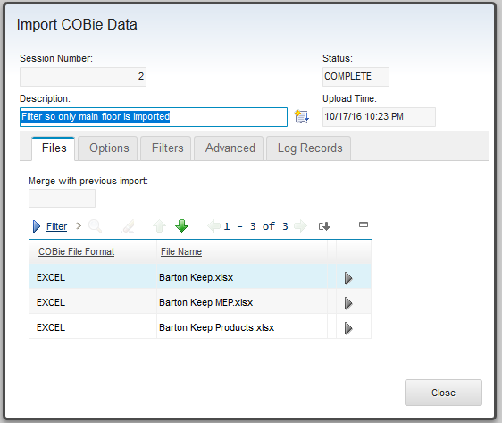

Select “New Row” and then select the COBie Sheet lookup to bring up a list of supported COBie data. Then select the File Name lookup to bring up the file selection dialog. Repeat this process until the desired import files are defined. The COBie Sheet field takes an individual COBie table name for use with CSV import or EXCEL for a full spreadsheet import.

The search button allows selection of files for upload from the local file system. If the import type is .csv, any valid URL maybe specified instead of a file from the local file system.

Any combination of CSV, .xls, and .xlsx may be specified. All data must reference the same facility. However, duplicate records, including duplicate facility specifications are merged. If the original model consists of many linked files, a COBie file may be generated for each model file, and then be merged at this step, or as multiple import sessions.

If the import file type is Excel, the table row can be expanded to select which COBie tables are imported.

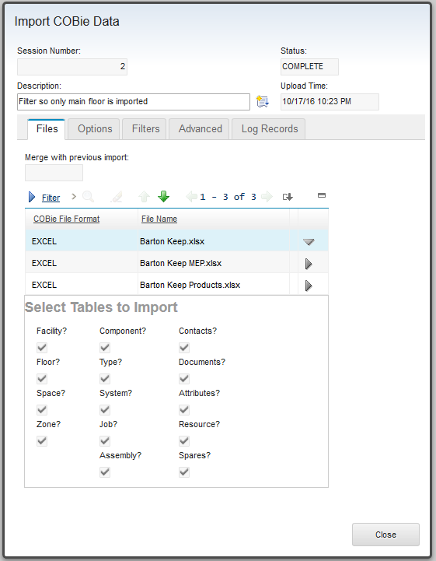

More than one import file may contain a facility. This is common when multiple Excel files are specified on a single upload, such as an architectural, a MEP, and a structural. The COBie standard requires that there be exactly one facility. If the facility contained in each file has the same name, they are merged. If facilities with different names are encountered an error is reported and no data is imported. To resolve do any of:

* Use the incremental import described below,
* Edit you COBie data prior to import so there is either only a single facility or all facilities have the same name,
* Use the import selection checkboxes to exclude some of the facility tabs.

#### Merging Data

Depending on the context one or both of the “**Merge with Existing Maximo Data**” or “**Merge with Previous Import**” fields may be displayed.

* **Merge with Existing Maximo Data:** Visible for Merge and Validate sessions when no previous import or update in the project has completed successfully. The Lookup provides a list of Locations that are children of the location selected as the Project Parent Location.
* **Merge with Previous Import:** Visible for Import, Update, and Validate sessions when a previous Import or Update has completed successfully. The lookup provides a list of the Facility Locations created by Imports or matched by previous Merge with Existing sessions.

In either case, selecting a value for the field cause all Facility records found on Import, Update, or Validate to automatically match to that selected Location.

See 2.4 Merge for details of how import and update date is matched to and merged with existing Maximo data.

#### Starting a Session

The Validate, Import, Merge, Update, or Export button initiates a session and switches the dialog to the log Records tab. The session runs in the background. The dialog or the browser may be closed without impacting it. The refresh button updates the log and percent complete.

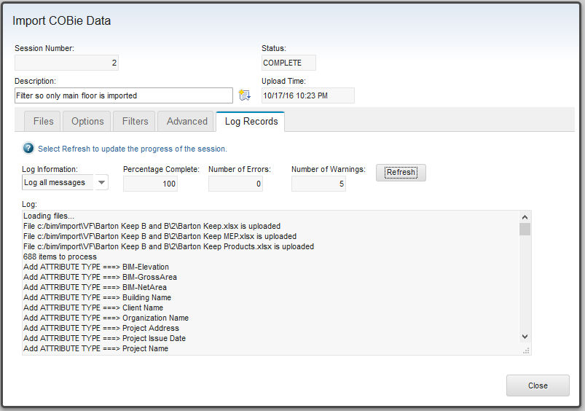

Figure : Session Log

A new session cannot be created while there is an active session. However, if the Maximo server is stopped while an import is active the import session is left in the importing /validating state and cannot be recovered. To address this, a query is run on server start the finds and fixes such sessions setting them to the “Failed” state.

### Validate Sessions

Validate sessions validate COBie data without making any changes to the Maximo database. Validation messages are shown on the Log Records tab. Validation is a two-step process:

* Validation the integrity of the COBie file
* Validating against the Maximo database

If an existing Maximo location is selected, COBie data can be validate against existing Maximo data and uses the enhanced matching algorithm. (See 2.3.4 Update Session)

The following validations are performed:

* **COBie file integrity**
  + **Duplicate Items**: Test that each item on a sheet is unique based on the identifying fields for that sheet. If multiple files are provided on the import, then the same item in different files is not reported as a duplicate. Duplicate items in different files are merged.
  + **Missing References**: Validate that ever space has a reference to a floor and every component has a reference to a space. This only validates that value are provided not that the references are valid. A value of n/a or similar is treated as no value.
  + **Missing Sheet Reference**: For the attribute and documents tabs, validate that the Sheet column has a value. Variant of n/a are treated as no value.
  + **Missing Row Reference**: For the attribute and documents tabs, validate that the Row column has a value. Variant of n/a are treated as no value.
  + **Unresolved Reference**: Any place a COBie item references another item, validate that the referenced item exists.
  + **Space List:** Report if a Component references more than one space. The COBie specification allows a Component to have a comma separated list of space references. However, the import only supports a single parent for a Component. The first space in the list is used.
  + **Value List Mismatch**: Report if two attributes with the same name declare different lists of valid values.
  + If Use FloorTag, Use RoomTag or Use Barcode as Asset ID are selected, each of these fields are checked for uniqueness and an error is issued if duplicate values are found.
* **Maximo database**
  + **Primary System:** Verify that the selected parent location for the project is a member of the primary system for its site.
  + **Unit of Measure References**: Validate that all units specified in the import files exist in the Maximo Unit of Measure table
  + **Categories**: Validate that all categories listed in the input files are valid Maximo classifications and that the classification have a Use With value for the object type.
  + **Documents**: Validate that listed documents exist in the document import directory, that they do not exceed the maximum attachment size configured in Maximo, and that they are a valid type based on their extensions. Also test if a document with the same name but different checksum exists.
  + **Location values**: If one of the options for user specified or structured location values is selected validate that the values don’t exceed the maximum length of the location field.
  + **ID Fields**. The length of many of the IDs generated from COBie data is check to determine if they fit the target Maximo field.
  + If “Log All Messages” is selected, show what records match existing Maximo data, and what records would be added.

Once validation is run the session is complete. A new session must be created to repeat the validation or to run an import.

|  |  |
| --- | --- |
| Tip | *Select log all messages to see a listing of every item that would be imported, and that matches an existing Maximo record. This can be used to test filters.* |

### Import Sessions

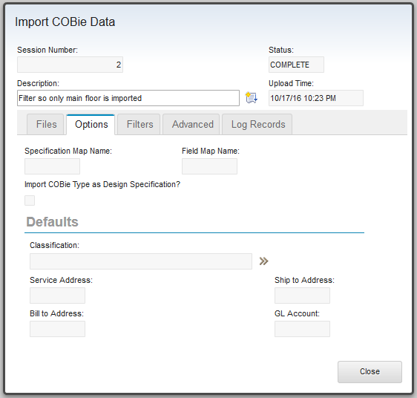

#### Import Options

* A Specification Map and/or Field Map may be associated with an Import Session. (See 2.6 Custom Attribute Mapping). Session level maps override project level maps
* **Import COBie Types as Design Specification**: If this box is checked, Design Specifications are created for COBie Type entries instead of Products. Design Specifications are linked to the operating location for the asset, not that asset. Design Specifications ignore some of the type data, are not linked to Job Plans, and no Master PM Records are created. This option is not valid if Operating Locations are not used.

#### Default Values

The defaults tab allows several default values to be specified for the records created by the import. The address and accounting information is copied to every location created by the import.

* **Classification**: Specify a Maximo classification for the location created for the facility. If this value is specified, it overrides the site level specification of the facility classification. It may be overridden by OmniClass or other classification attributes found in the import.
* **Addresses:** Defaults for the address for locations created by the import
* **GL Account**: If set, will be used for all locations created by the import

#### Filters

A list of filters may be associated with a validate, import, merge, or update session. (See 2.5 Import Filters). The description text in the filter table is pre-populated from the filter description, but may be updated. For an item to be imported, it must pass all filters.

A Validate session with “Log All Messages” selected can be used to verify filter behavior.

### Update Session

Data in a previously imported facility may be updated with update sessions

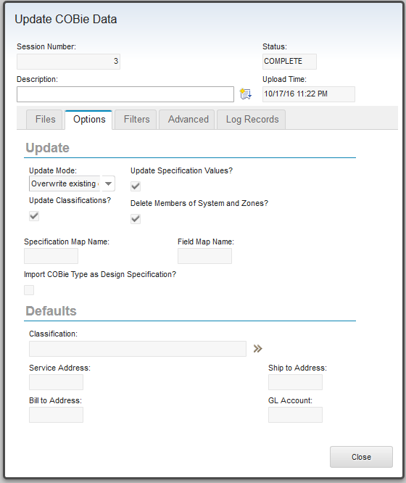

Figure - Update Session Options

There are three update modes:

* **Update Blanks Fields:** When an existing record matches an update record, each updatable field is checked to see if it has a value. If it doesn’t, and there is a value in the update data, the value is added to the record.
* **Timestamp bases:** For Maximo records that support the CHANGEDATE field. The value of the CHANGEDATE field is compared to the COBie CreatedOn field. If both dates are valid, and the COBie CreatedOn date is newer than the Maximo CHANGEDATE, than every COBie field that has a valid value is updated in the Maximo record.
* **Overwrite:** For every Maximo record that matches a row in the import data, every COBie field that has a valid value is updated in the Maximo record.

Values that are used in the matching process and values that are read-only in Maximo usually can’t be updated. See chapter 6 COBie to MAXIMO Field Mapping for a detailed listing of which fields are updatable.

Update options as describe below control specific update behaviors:

* **Update classification:** Change the classification of Maximo records based on the COBie Category field.

1. Changing the classification causes all Specifications associated with the record to be deleted. This happens before attribute are updated so the current import may restore some or all of the deleted attibutes.

* **Update Specifications values:** Update the value of the Maximo specifications from the COBie attribute tab. Note: Several import options control where specifications are created. If these options are not the same for the update session, then new specifications may be created instead of existing ones being updated.
* **Delete Members of systems and zone:** Updates Maximo systems to exactly match the COBie system or zone definition, including deleting any members that don’t appear in the update data.

The remaining options are the same as the Import options

The following Maximo records support CHANGEDATE and can be updated by the timestamp mode:

* LOCATIONS (Facility, Floor, Space)
* ASSET {Component)
* COMPANIES (Contacts)
* BIMPRODUCT/DESIGN SPECIFICATION (Type)
* SPECIFICATION

Update Behavior:

* **Company/Company Contacts:** New company contacts can be added, but no fields in an existing company of contact can be updated.
* **Maximo Systems:** New members are added, and if desired, members can be removed.

### Merge Sessions

COBie data may be overlaid on top of existing Maximo data for the facility in the COBie data The Merge session can be used to merge COBie data with existing Maximo locations. To enable this, select a location for the Merge with existing data field.

The selected location is automatically matched to the COBie facility record. Floors, Spaces, and Components use a modified matching algorithm:

* If structured IDs are used for the Location field of the Floor or Space, then an attempt is made to match these against existing location records. This match only considers children of the previously matched parent location. So a Floor must match before an attempt is made to match spaces, and only locations that are beneath the floor in the primary system are considered.
* If the Sue Bar Code as assetnum” options is selected, assets are searched for a match that is in the correct location subtree.
* For Floors and Space: when matching the COBie name against the description, the value of the BIMUsage field is ignore
* For Floors, Spaces, and Components: COBie records that specify an External Identifier and fail to match to a Maximo ModelID attempt a name match to Maximo records without ModelID values.

When a Merge matches COBie data to existing Maximo data, the Maximo record has its ModelId, BIMUsage, and BIMSource values set make the record appear as if it was created by a COBie import for all future COBie interactions.

Other Merge options are the same as those on the Update session.

### Export Sessions

Export session extracts data from Maximo and writes it to an Excel .xlsx file. The file name is created by concatenating the site name, the project prefix, and the session number. It is attached to the project and may be viewed and downloaded by opening the attachments. This file ignores the maximum file size configuration for attachments.

The export traverses Maximo relationships starting at the Facility location to gather the data for export. If uses the following search criteria:

**Facility:** The specified facility with data taken from both the facility import session and the facility location

**Floors:** All locations that are descendants of the Facility location and have their BiMUsage field value set to “Floor”

**Space:** All locations that are descendants of the Facility location and have their BiMUsage field value set to “Space”

**Component:** Any asset that has a location that is a child of the facility location.

**System and Zone:** All LocStstems that are not the primary system, and have the facility as a member location with no parent. If a member of the system is a space as defined above, it is added to the Zone with the name of the LocSystem. If a location is a member of components as described above, it is added to a system with the name of the LocSystem. If the zone has members it is exported, if the system has member it is imported. This implies that a single Maximo system can be exported as both a system and a zone with some of its member in each.

**Type:** All Products that are referenced by any asset that has a location that is descendant of the facility in the primary system.

**Jobs:** All Job plans that are referenced by any product in the above list.

**Contacts:** The Maximo user that requested the export. This is the value of the CreatedBy field for every record in the export. And the primary contact for any company referenced by any product in the above list.

**Attributes:** Specification for any of the above that supports them

**Document:** Attachments for any of the above that supports them.

Note: It is possible to do a stub import that only has a facility, and then manually create the structure required for the export. However, Maximo allows structures that are not compliant with the COBie specification, especially with the location hierarchy. So some care must be taken. It is also possible to use the Merge Session to establish the require BIMUsage values.

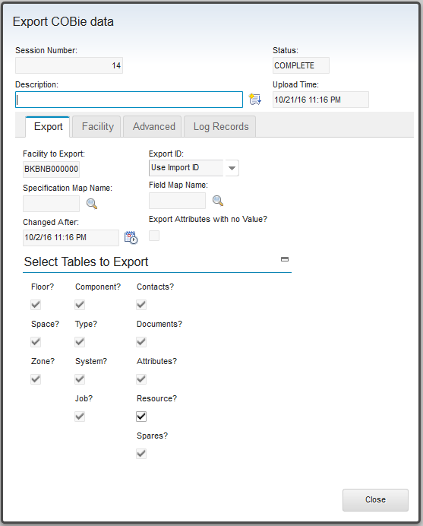

Figure – COBie Export Session

* **Facility to Export**: Select a facility that was previously imported in this project. Only facilities that were created by a COBie import or data that was merged into a COBie import can be exported.
* **Export Id**: Controls how the COBie ExternalIdentifier field is generated. The COBie ExternalObject field echoes the above selection
  + **Import ID:** Uses the ModelId field for the COBie ExternalIdentifier. Typically, this was set by the import. Selecting this option is useful for synchronizing data back to the import source such as an IFC or Revit file. The ExternalObject field is not saved on Import. It is assumed that it was an IFC object type. Where a single IFC type applies to the entire table, that value is used. Otherwise the field is left blank.
  + **Maximo UID:** Uses Maximo database sequence number for the COBie ExternalIdentifier. This is useful for exporting data that need to interact with Maximo through web services or other APIs. The Maximo Business Object that was the source of the export is used for ExteralObject.
  + **IFC, UID:** Provide both of the above in comma separated format. The COBie standard does not specifically define this format. However, many other COBie fields do use a comma separated list format. It is unlikely that existing imports will be able to consume this, but it may be useful for custom applications that need to relate the two values. The ExternalObject is a comma separated pair of the above options. Note the left side of the pair may be blank.
* **Select table to export**: List of desired COBie tables to be created by the import.
* **Specification Map**: An Specification Map to use with the export. Changes the names of Maximo attributes in the exported COBie file.
* **Field Map**: An Field Map to use with the export. The Field Map causes data stored in fields in Maximo Business Objects to be exported as COBie attributes. It is typically used to export data stored in custom fields.
* **Change After**: Specify a filter data for exporting components. Only assets with a CHNAGEDATE later than the specified date are exported. If no date is specified, no assets are exported.

The export also uses any mappings specified on the Mapping tab of the Project.

## Merge with Existing Data

A single facility may be built up though multiple import session. Import data is matched against existing Maximo data.

* For an import session when import data matches existing data, the existing data is unaltered, but all references within the COBie file to the record that matches now reference the existing Maximo data. For example: if a component matches an existing asset, all attributes and documents that reference the component now reference the asset. This may cause specifications and attachments to be added to the asset.
* For Update The existing data is updated based on the update behavior selected for the session, and references behave as for import.
* For Merge, The ModelId, BIMUsage and BIMSource fields are always set, and then the update behavior is used.

Each import matches against existing data as follows:

* **Facility:** If a value is specified for the “Merge with Previous Import” or “Merge with existing” field, no matching is performed and the facility specified in the new import session is ignore. All data is added to the specified facility. Otherwise, previous sessions in the project are searched for a matching facility. It first tries to match on ExternalFacilitiesIdentifier, then on facility name. If both fail, a new facility is created and all floors, spaces, and components are imported under the new facility.
* **Floor**:
  + If the facility did not match, no attempt is made to match the floor.
  + If any Option to construct the Floor ID from COBie data is selected, and the ID is successfully constructed, Child locations of the facility in the Maximo primary system are searched for a record whose Location field matches the ID
  + Child locations of the facility in the Maximo primary system are searched for a match of ExternalIndenrifier to the Maximo ModelId.
  + If no COBie External Identifier is specified, child locations of the facility in the Maximo primary system are searched. For a record whose description is a case insensitive match of the Floor Name, with a null Model ID and a BIMUsage value indicating it is a floor.
* **Space**:
  + If the floor did not match, no attempt is made to match the space.
  + If any Option to construct the Space ID from COBie data is selected, and the ID is successfully constructed, Child locations of the floor in the Maximo primary system are searched for a record whose Location field matches the ID
  + Child locations of the floor in the Maximo primary system are searched for a match of ExternalIndenrifier to the Maximo ModelId field.
  + If no COBie External Identifier is specified, child locations of the floor in the Maximo primary system are searched. For a record whose description is a case insensitive match of the Space Name, with a null Model ID and a BIMUsage value indicating it is a room.
* **Component:**
  + If the COBie parent object, which could be a space, a floor, or the facility did not match a Maximo record, no attempt is made to match the Component.
  + If “Use Barcode for assetnum” is specified for ID generation and a Barcode is specified, the asset table is searched for an asset who’s assetnum matches the barcode in the site of the project and whose location is a decendent of the parent object.
  + The locations table is searched for a match of the ExternalIdenrfier to the Maximo modelId with a location that is a child of the parent object in the Maximo primary system and a BIMUsage value indicating it is.an operating location. If a match is found and it has exactly one asset, it is used or if it and all asset that share the operating location are part of a single asset assembly.
  + The, COBie name is matched ignoring case against the Maximo description where the ModelID is null.and the location is a child of the facility and a BIMUsage value indicating it is.an operating location. If a match is found and there is exactly 1 asset at that location or a single asset assembly of which the asset is a member, the location and asset are used. If there are more than one asset, the list is search for a match of the ExternalIdenrfier to the Maximo modelId. If a match is found, the location and matching asset is sued.
  + The Asset table is searched for a match of the ExternalIdenrfier to the Maximo modelId with a location that is a child of the parent object in the Maximo primary system.
  + If no COBie External Identifier is specified, the COBie Component Name is matched ignoring case against the Maximo asset description where the ModelID is null, and the location is a child of the parent object.

If a component references a type that does not exist in the import data, the import attempts a name match against the product table to resolve the reference. This is intended to support using SPie data to build a reusable product library.

* **Zones and Systems:** If the facility did not match, no attempt is made to match zones or systems. Otherwise the locsystem table is searched for a system for which the facility is a member, the ExternalItendirifer matches the system’s ModelId field, and is not the primary system. If that fails, a similar search is made to match the COBie name against the system description where the ModelId is null.
* **Product:** If the import Type has an External Identifier, and it matches an existing Product, the matching Product is reused. If the COBie Type specifies a model number, the Maximo product table is searched for products with the same model number and the same organization as the facility location. If the COBie Type does not specify a model number, the Maximo product table is searched for products with the same name (case insensitive) and the same organization as the facility location. A heuristic is applied to the result of whichever search was performed to determine if the product is a match. The heuristic considers various descriptive elements such as size and category/classification.

Product reference companies for the manufacturer, and warrantee guarantor. According to the COBie specification, these should be references from the Type entry to Contact entries. If there are, the references are processed normally. However, if the COBie parse failed to match a Contact to any of these references, the import attempts to find an existing Company that matches. If the value is a valid email address, Company Contacts are searched for a contact with a matching email. If exactly one match is found, that company is used. If it is not a valid email, Companies are searched for a Company with either a matching name or a matching HomePage. If exactly one match is found, the Company is used. All matches are case insensitive.

* **Design Specification** Matches similar to product, but there is no Make, Manufacturer or Model Number.
* **Person:** First a case insensitive search is made for a person that has an email that matches the COBie email field. If this fails, a case insensitive search is made for a person with a personid that matches the COBie email field.
* **Company:** If the Contact email column contains a valid email address, Company Contacts are searched for a match. If exactly one match is found, the parent Company is used. If Contact name is not a valid email or no match is found, Companies are searched for a case insensitive match of the COBie company field against the Name filed of the companies table. If no company is found, but a company master matches, a company is created from the company master.
* **Jobs:** Job Plans are searched for a case insensitive match of the COBie name field against the Job Plan description. If the “If the Job Play Creation Level” import option is set to organization or site, the Job Plan must have an organization or organization and site specified and they must match the facility.
* **Document:** The Maximo attachment files are searched for a file with the same name and MD5 checksum.
* **Attribute Types:** COBie doesn’t have the concept of attribute types. To support the Maximo requirement for attribute type. The import infers attribute type by analyzing attributes with the same name. Once attribute types have been inferred from the COBie file they are matched against Maximo attribute type using the following rules:
  + The Maximo attribute type list is searched for a numeric attribute that matches the COBie attribute. If a match is found and the COBie attribute type is numeric, it is valid match and is used. If the COBie attribute type is Alpha Numeric:
    - If the match is against the AssetAttrib, The COBie attribute type is marked as unusable. No values will be imported for this attribute type. A type mismatch warning is issued.
    - If it is against the description, no match is reported. It may later match a Maximo Alpha Numeric attribute type, or if it doesn’t, the import will create a new Alpha Numeric attribute type.
  + The Maximo attribute type list is searched for an Alpha Numeric attribute that matches the COBie attribute type. If a valid match is found the match is used.
  + For both of the above searches, the Maximo attribute list is first searched for an attribute type where the COBie attribute name matches the Maximo AssetAttrib, then an attribute where the COBie name matches the Maximo attribute description
* **Attributes:** If a record has an attribute value with the same attribute type, then it matches.
* **Assembly** If the parent Component in the Assembly matched to a Maximo asset, and both the Assembly specifies children, and the asset has children, then the Assembly matches.

For everything but Document, Attribute Type, Attribute, and Assembly, there is a special matching rule that is tested first. If:

* The COBie ExtSystemName field has the name of the Maximo system. Typically, MXSsystem
* And The COBie ExtSystem field has the name of the Mbo currently being matches.

Then the COBie ExternalIdentifier field is assumed to have the UID of the target Maximo record. If a record with that UID is found, then it matches. Typically, this is used when re-importing COBie data that was created by an Export session but may also be used to control merges with existing Maximo data.

## Import Filters

Import, merge, update and validate session can have filters applied to restrict what is imported. Filters are defined independently of projects then applied to a session. A single filter may be reference by any number of sessions. This provides for a library of reusable filters.

Filters are applied immediately upon reading a row from the input file so use of filters can reduce memory usage.

A Validate session can be run with Log All Messages selected to see the effects of a filter except for attributes and documents which aren’t reported.

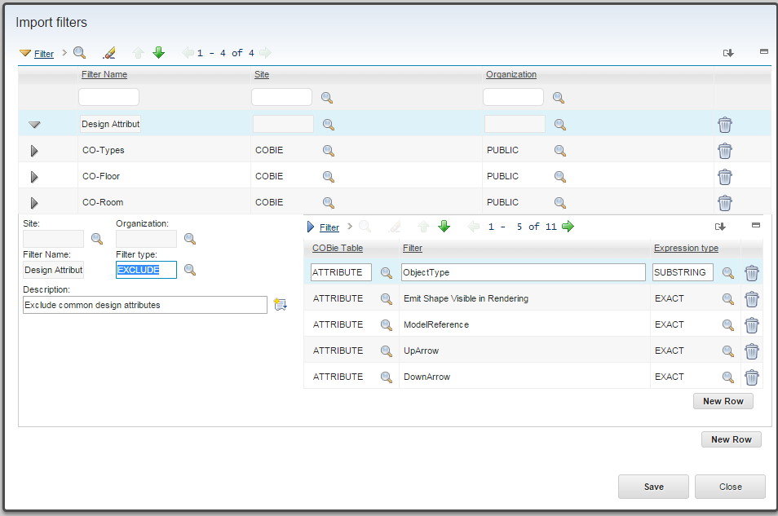

Figure - Import Filter

* **Site and Organization:** Filters may be created at System, Organization, or Site level.
* **Filter Type:** A filter may be either an inclusive filter or an exclusive filter. The type applies to all entries in the filter.
  + **Exclude:** For each row read from a COBie spreadsheet or CSV file, the row is tested against every entry in the filter. If the row matches any entry it is discarded.
  + **Include:** For each row read from a COBie spreadsheet or CSV file, the row is tested against every entry in the filter. If it does not match any entry, it is discarded. However, if there is no entry for a given COBie table, then that table is not filtered and all rows are used.
* **COBie table**: The COBie table or tab to which a filter entry applies. A single entry can only apply to a single table.
* **Filter:** This string is matched against the key value of each input row. With the exception of Contact, that is the Name column, for Contact it is email.
* **Expression Type:** Controls how the filter is applied to the input rows.
  + **Exact:** A case insensitive comparison is performed on the filter and the key value for each row tested. If they are identical, the filter matches the row.
  + **Substring:** Both the filter and the key value for each row are folded to upper case. Then the key value is searched for the filter. If the filter string appears anywhere in the key value, the filter matches the row.
  + **Regular Expression:** The key value is folded to upper case. The filter is treated as a regular expression defined here:

<http://docs.oracle.com/javase/1.4.2/docs/api/java/util/regex/Pattern.html>

If the key matches the regular expression, then the filter matches the row.

Filters process references that are inherent in a single row of data. References are tested before the row is tested and if the referenced row is excluded, the row being tested is also excluded. The following references are tested:

* Attribute references using both sheet and row
* Document references using both sheet and row
* Component references to a space
* Component references to a type
* Job reference to a Type

Additional processing is provided to support filtering by floor. Spaces that reference an excluded floor are excluded, and then references to the Space are also excluded as described above.

Since the filter is applied immediately upon reading a row, references are not yet resolved and in fact referenced objects need not have been read. Therefor the above behavior is only one level deep. For example, if a space is excluded causing components that reference it to be excluded, attributes and documents that reference the components are not excluded. However, the attribute and documents will not ultimately be imported since attributes and documents are imported as part of the object they reference. A Validate session will report unresolved references for these attributes and documents.

## Custom Attribute Mapping

Attribute Maps allow COBie attributes, and by extension, COBie extension columns since they can be converted to attributes, to be mapped to fields in the base Maximo object or to Maximo Attribute Types used for Specifications. This is particularly useful for Maximo installations that have been extended with custom fields.

Maps are applied when fields are set in a newly created import or export object. So although they can functionally overlap with filters, they are applied much later in the process which may be useful.

Attribute maps apply on both import and export so they can be used to export a custom Maximo field to a COBie attribute

There are two type of Attribute Maps:

* Specification Maps: These effectively change the name of a COBie attribute. They also circumvent all of the attribute type matching rules
* Filed Maps: These redirect COBie attribute data from specification to fields in the base Maximo record.

Both attribute and field maps are defined independently of a project, then associated with the project or an individual session.

Both types of maps may be created a System, Origination, or Site level.

If a COBie attribute listed on a map doesn’t appear in a model the map is applied to, it is ignored.

|  |  |
| --- | --- |
| Tip | *A Merge session with the Log Level set to all produces a list of all the attribute type in the COBie file(s) processes in the session.* |

### Map to Specification

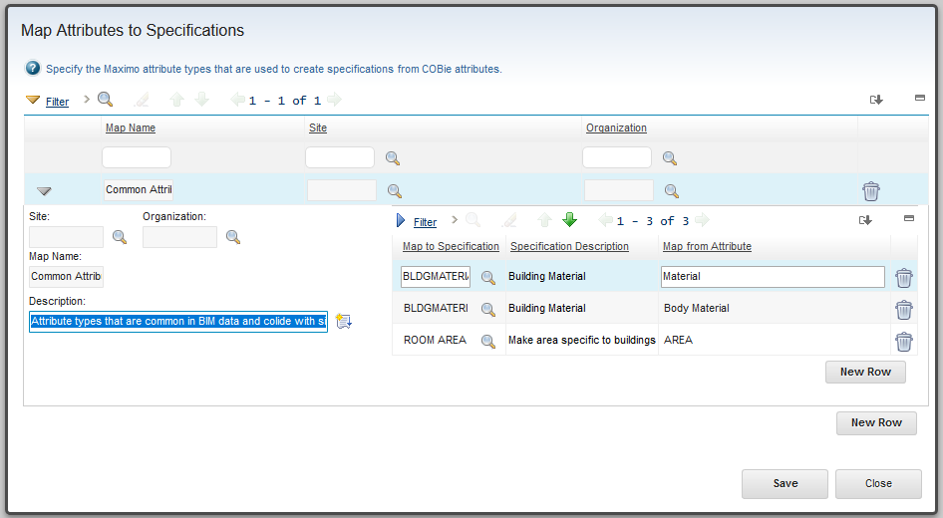

Figure - Specification Map

* **Map to Specification:** A Maximo Attribute definitions (Administrant->Classifications->Select Action ->Add/Modify Property->Attributes).
* **Speciation Description**: Populated by the lookup from the Maximo attribute definition.
* **Map From Attribute**: The name of the COBie attribute that is the source, or for export, target for the data.

A row in the mapping table causes the “Map From” Cobie attribute type to be mapped to the “Map to Specification” Maximo attribute instead of the Maximo attribute list being search for a match or a new attribute definition created. This results in Specification entries for the “Map to Specification” attribute with values for the “Map From” Attribute.

### Map to Field

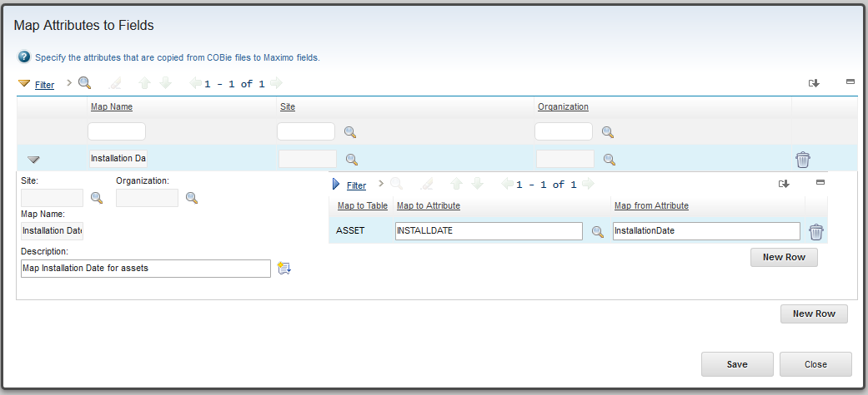

Figure - Field Map

* **Map to Attribute:** The Maximo table and attribute to which the attribute value is to be copied. The following filter is used to select that attribute.

objectname IN ( 'ASSET', 'LOCATIONS', 'BIMPRODUCT', 'BIMDESIGNSPEC', 'JOBPLAN', 'ITEM' ) and RESTRICTED = 0 and DOMAINID is NULL and PERSISTENT = 1 and ( SAMEASOBJECT is null OR SAMEASOBJECT = 'BIMPRODUCTBASE' )" and PRIMARYKEYCOLSEQ is null and not ( MAXTYPE IN ( 'BLOB', 'CLOB', 'CRYPTO', 'CRYPTOX', 'GL' ))

The filter is defined as the FIELDS relationship on the BIMATTRIBUTEMAPENTRY Table. It may be edited using the database configuration application.

The Map To Table is automatic populated based on the selected attribute. The attribute may be cleared which prevents the “Map From” attribute from being imported for that table. The entire field may be left blank which has the same effect as filtering out the attribute

* **Map From Attribute**: The name of the COBie attribute that is the source, or for export, target for the data. If it is blank or doesn’t exist, the field is left blank. Multiple COBie attributes may be mapped to a single Maximo field. If more than one exists for a single object instance, they are processed in the order encountered with the last attribute that has a value being the one that prevails.

### Adding Attribute Maps to Projects

Attribute maps are associated with Projects on the Mappings tab of the project applications. Maps associated with a project are applied to every session created for the project. A single Specification map and a single field map may be associated with a session. These maps are processed after the project level maps so they can override project level mapping.

Best practice is to associate attribute maps at the project level. The specification map at the session level can be used to correct deviations from data standards for a single file or model. Field maps at the session level are retained for backward compatibility.

Any number of maps can be associated with a project so a library of attribute maps with functional or other grouping can be developed to support an origination’s data standards.

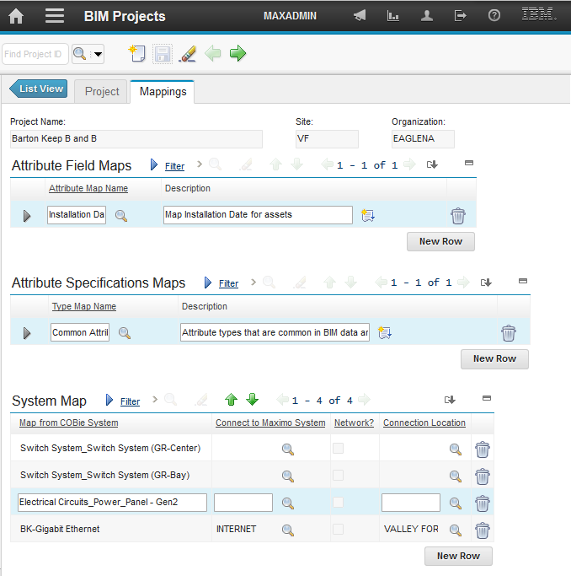

## System Mapping

Building models tend to create a large number of small system, and by their nature, these systems are specific to a single building. Maximo tends to have a small number of large systems, often that span a site. To resolve this mismatch: the BIM import has system maps. A system map directs the import to extend an existing Maximo system with the elements specified in a COBie system instead of creating a new Maximo system. System maps are specific to a project. They are defined on the Mappings tab of the Project application.

A system map entry has the following elements:

**Map from COBie System**: A name of a system from one of the COBie model file

**Map to Maximo System**: The name of the Maximo system which is to be extended with COBie data.

**Connection Location**: A location that is a member of the selected Maximo system. If the selected system is a network system this field can be blank.

When a system is mapped, the import:

* Creates a new location using either import generated IDs or Autokey based on configuration options. Its description is the name of the COBie system. It is a member of the Maximo system being extended, and its parent in that system is the connection location
* The operating location associated with each Component in the COBie system is added to the target Maximo system as a child of the location created in the previous step



The system mapping table for a project may be populated with a list of all systems appearing in a model by selecting the “Populate System Map” option in the session dialog. System map entries that don’t have a Maximo system associated with them are ignored

## Advanced Options

There are many advanced options to tailor the behavior of Import, Merge, Update, and Validate sessions. Typically, these are configured at the site level then copied to each session. However, the site level values may be overridden in a specific session.

There are two role based dialogs for configuring advanced options at the site level:

* Configure Model Data
* Configure Maximo Data

### Configure Model Data

To set the model data options for a site: from the main tab of the import applications:

Select Action->Configuration Import Data->Configure Model Data

The import configuration is displayed for the site of the import project.

#### COBie File Processing

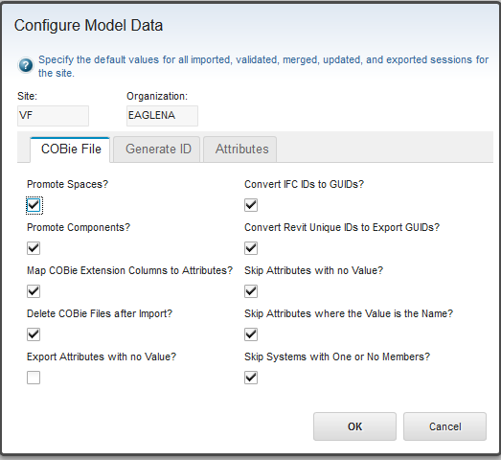

Figure – Upload dialog options tab – COBie File

* **Promote Spaces:** Maximo requires all locations to have a valid parent. If this option is selected and a space has a missing or invalid floor reference, the space is imported as a child of the facility. If it is not selected, spaces with invalid floor references are not imported
* **Promote Components:** COBie components often lack a proper space reference. If this option is not check, these components are skipped on the import. If it is checked, the model loader attempts to find a valid parent.
  + If the “Use Level Attribute” box is check and a valid level attribute exists, the value in level attribute, which must be a floor reference, is used as the parent of the Component.
  + An attempt is made to resolve the space reference as a reference to a floor. This behavior is outside the COBie specification, and the data must be specifically prepared to support this behavior. However, many models either lack space definitions, or some components are not associated with a space but they typically must be associated with a level.
  + If the space reference does not resolve as a valid floor reference, then the component is inserted as a child of the facility.
* **Map COBie extension columns to Attributes:** The COBie specification allows arbitrary user defined columns to be added to any COBie table. If this option is selected, any additional columns are converted to COBie Attributes with an Attribute name of the column name, a value of the cell value a sheet reference of the table to which the column belongs, and a row reference of the row the cell belongs to. This occurs when the file is loaded. All downstream processing such as attribute maps treat these columns as attributes.
* **Delete model files after import:** If this option is selected, the import files are deleted from the server file system after the import has completed
* **Export Attributes with no Values**: On export if a Maximo record has a specification listed, but the specification does not have a value assigned, the export normally skips it. If this option is checked, it is exported. If attribute types are assigned to a Maximo classification, or specified in an asset template without a value, then it may be common to have specifications without values.
* **Convert IFC IDs to Guids**: If this option is checked, the loader uses a heuristic to attempt to determine if the COBie external ID is a Guid, typically in base 64 format used by IFC. If it is it converts it to standard Hex Guid format. This must be checked for the visualization to work with the import for most NavisWorks and Revit files

<http://thebuildingcoder.typepad.com/blog/2009/02/uniqueid-dwf-and-ifc-guid.html>

* **Convert Revit Unique IDs to Export GUIDs**: Autodesk Revit has two representations for internal identifiers: A standard 32 hex character GUID, and an internal unique identifier that appends an 8-digit element ID onto a GUID. The Revit COBie toolkit produces COBie files with the unique ID for the external ID value, but the Forge viewer requires the standard GUID. If this option is selected, the import applies the required conversion.
* **Skip Attributes with No Value:** Attributes from the Attribute tab that have no value are not imported
* **Skip Attributes Whose Value is their Name:** Revit defaults many attribute values to the name of the attribute. If this box is checked, attributes whose name is their value, are not imported. In addition, some other COBie fields are check for their name being equal to their value. These fields are treated as having no value.
* **Skip systems with one or no members**: When systems are created from the Revit System Name attribute, often many systems with a single member are created. If the option is selected, systems with zero or one member are skipped on imports

#### Generate ID

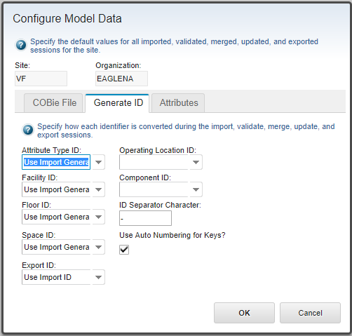

* **Attribute Type ID Generation**: This controls how the ID is generated for the Maximo Attribute definitions.
  + Import generated ID: A sequence number ID is generated by the import in the form BIMnnnnn where nnnnnn is calculated to the length of the AssetAttID field and is right zero padded.
  + COBie Name. The COBie name is used if it fits in the AssetAttID field. If it doesn’t fit, the Import Generated ID is used.
  + COBie Name Truncated to fit. The COBie name is used. If it is too long, it is truncated to the field length. This might result in it not being unique. If so creation of subsequent Attribute Types with the same (truncated) ID fail with a duplicate key error.
* **Facility ID Generation:** This controls how the value of the Location fields is derived for locations created from the COBie Facility tab
  + **Use Maximo Auto Key:** Use the Maximo generated auto key for the location record. This requires that Auto Key is enabled and configured for Locations. If no Auto Key value is available, the prefix + sequence number value is used
  + **Use Import Generated ID:** Use the Key value auto generated by the import utility for the prefix specified in the project. See 2.3.1
  + **Use Prefix:** Use the Prefix specified for the Project as the Location Field
  + **Facility Name**: Use the Facility Name specified In the COBie file as the Location Field.
* **Floor ID Generation:** This controls how the value of the Location fields is derived for locations created from the COBie Floor tab
  + **Use Maximo Auto Key:** Use the Maximo generated auto key for the location record. This requires that Auto Key is enabled and configured for Locations. If no Auto Key value is available, the import generated ID value is used
  + **Use Prefix and Floor Name:** Use the concatenation of the Prefix specified for the project, and the name of the floor in the COBie file. If a separator character is specified it is inserted between them. If the resulting value is too long for the location field, Auto Key or import generated ID is used instead depending on options selected.
  + **Use Import Generated ID:** Use the Key value auto generated by the import utility for the prefix specified in the project. See 2.3.1.
  + **Use Floor Tag:** Use the value of the FloorTag from the floor record. This value must be unique for the site. Import of the floor will fail if it is not. If there is no value for the FloorTag, or the value is too long for the location field, the import generated ID value is used unless the “use auto number for keys” box is check in which case the auto key is used if it is available.
  + **Use Prefix and Floor Tag:** The value for the FloorTag from the Floor record is concatenated onto the prefix specified for the project. If a separator character is specified, it is inserted between them. The FloorTag must be unique across all floors in the project. Import of the floor will fail if it is not. If there is no value for FloorTag, or the result of the concatenation is too long for the location field, the import generated ID value is used unless the “use auto number for keys” box is check in which case the auto key is used if it is available.

|  |  |
| --- | --- |
| Note | *FloorTag is a Maximo specific extension to the COBie standard. To utilize it, simple add a column to the Floor sheet with the header FloorTag.* |

* **Space ID Generation:** This controls how the value of the Location fields is derived for locations created from the COBie Space tab
  + **Use Maximo Auto Key:** Use the Maximo generated auto key for the location record. This requires that Auto Key is enabled and configured for Locations. If no Auto Key value is available, the prefix + sequence number value is used
  + **Use Prefix Floor Name and Space Name:** Use the concatenation of the Prefix specified for the project, the Name of the floor referenced by the space and the name of the space. If a separator character is specified it is inserted between each component of the ID. If the resulting value is too long for the location field, Auto Key or Prefix + Sequence Number is used instead depending on options selected.
  + **Prefix + Space Name:** Use the concatenation of the Prefix specified for the project, and the name of the space. If a separator character is specified it is inserted between them. If the resulting value is too long for the location field, Auto Key or the import generated ID is used instead depending on options selected.
  + **Use Import Generated ID:** Use the Key value auto generated by the import utility for the prefix specified in the project. See 2.3.1.
  + **Use Room Tag:** Use the value of the room tag from the space record. This value must be unique for the site. Import of the space will fail if it is not. If there is no value for the room tag, or the value is too long for the location field, the import generated ID value is used unless the “use auto number for keys” box is check in which case the auto key is used if it is available.
  + **Use Prefix and Room Tag:** The value for the room tag from the space record is concatenated onto the prefix specified for the project. The room tag must be unique across all spaces in the project. Import of the space will fail if it is not. If there is no value for room tag, or the result of the concatenation is too long for the location field, the import generated ID value is used unless the “use auto number for keys” box is check in which case the autokey is used if it is available.
* **Operating Location ID Generation**: This controls how the value of the Location fields is derived for operating locations created from the COBie Component tab
  + **Use Assetnum**: If the method used to generate the assetnum of the Component associated with the operating location is not an import generated id or an autokey and the value is short enough to fit in the location field, use the assetnum value. If not the import generated ID value is used unless the “use auto number for keys” box is check in which case the auto key is used if it is available.
  + **Use Maximo Auto Key:** Use the Maximo generated auto key for the location record. This requires that Auto Key is enabled and configured for Locations. If no Auto Key value is available, the prefix + sequence number value is used
  + **Use Import Generated ID:** Use the Key value auto generated by the import utility for the prefix specified in the project. See 2.3.1.
* Component ID Generation: This controls how the value of the Assetnum fields is derived for Assets created from the COBie Component tab
  + **Use Maximo Auto Key:** Use the Maximo generated auto key for the location record. This requires that Auto Key is enabled and configured for Locations. If no Auto Key value is available, the prefix + sequence number value is used
  + **Use Barcode as Assetnum**: If this option is selected: for any component that has valid data in the barcode field, and the value fits within the assetnum field, that value is used for the assetnum field of the asset record created for the component, instead of the sequence number generated by the import. If the bar code is not unique within the Site, an error is reported and the asset is skipped.
  + **Use Import Generated ID:** Use the Key value auto generated by the import utility for the prefix specified in the project. See 2.3.1.
  + **Use Component Name:** Use the the name of the component in the COBie file. If the resulting value is too long for the assetnum field, Auto Key or import generated ID is used instead depending on options selected. If the component name is not unique within the Site, an error is reported and the asset is skipped.
  + **Use Prefix + Barcode as Assetnum**: The value for the barcode from the component record is concatenated onto the prefix specified for the project. The barcode must be unique across all components in the project. Import of the component will fail if it is not. If there is no value for barcode, or the result of the concatenation is too long for the assetnum field, the import generated ID value is used unless the “use auto number for keys” box is check in which case the autokey is used if it is available.
  + **Use Prefix and Component Name:** Use the concatenation of the Prefix specified for the project, and the name of the component in the COBie file. If a separator character is specified it is inserted between them. If the resulting value is too long for the assetnum field, Auto Key or import generated ID is used instead depending on options selected.
* **Use auto numbering for keys:** If this box is check, when locations and Assets are created, an AutoKey values is used if it is available. Otherwise the sequence number generated by the import is used. Note: This behavior is overridden for the facility by the Facility ID option, for floors by the Floor ID Generation option, and for spaces by the Space ID Generation option and for Components by the Use barcode as assetnum option. Auto key must be enabled for Locations and Asset in Database Configuration.
* **Separator Character**: A single character that can be inserted between components of composite IDs.
* **Export Id**: Controls how the COBie ExternalIdentifier field is generated. The COBie ExternalObject field echoes the above selection
  + **Import ID:** Uses the ModelId field for the COBie ExternalIdentifier. Typically, this was set by the import. Selecting this option is useful for synchronizing data back to the import source such as an IFC or Revit file. The ExternalObject field is not saved on Import. It is assumed that it was an IFC object type. Where a single IFC type applies to the entire table, that value is used. Otherwise the field is left blank.
  + **Maximo UID:** Uses Maximo database sequence number for the COBie ExternalIdentifier. This is useful for exporting data that need to interact with Maximo through web services or other APIs. The Maximo Business Object that was the source of the export is used for ExteralObject.
  + **IFC, UID:** Provide both of the above in comma separated format. The COBie standard does not specifically define this format. However, many other COBie fields do use a comma separated list format. It is unlikely that existing imports will be able to consume this, but it may be useful for custom applications that need to relate the two values. The ExternalObject is a comma separated pair of the above options. Note the left side of the pair may be blank.

|  |  |
| --- | --- |
| Tip | *Use validate sessions to verify the IDs built for name or tag values are not too long for their target fields.* |

#### Attribute Mappings

The import utility can process information on the COBie attribute tab to fill in data that may be missing from other tabs. The attributes tab controls what values are processes and specifies the name of an attribute from the attribute tab to use for a specific value.

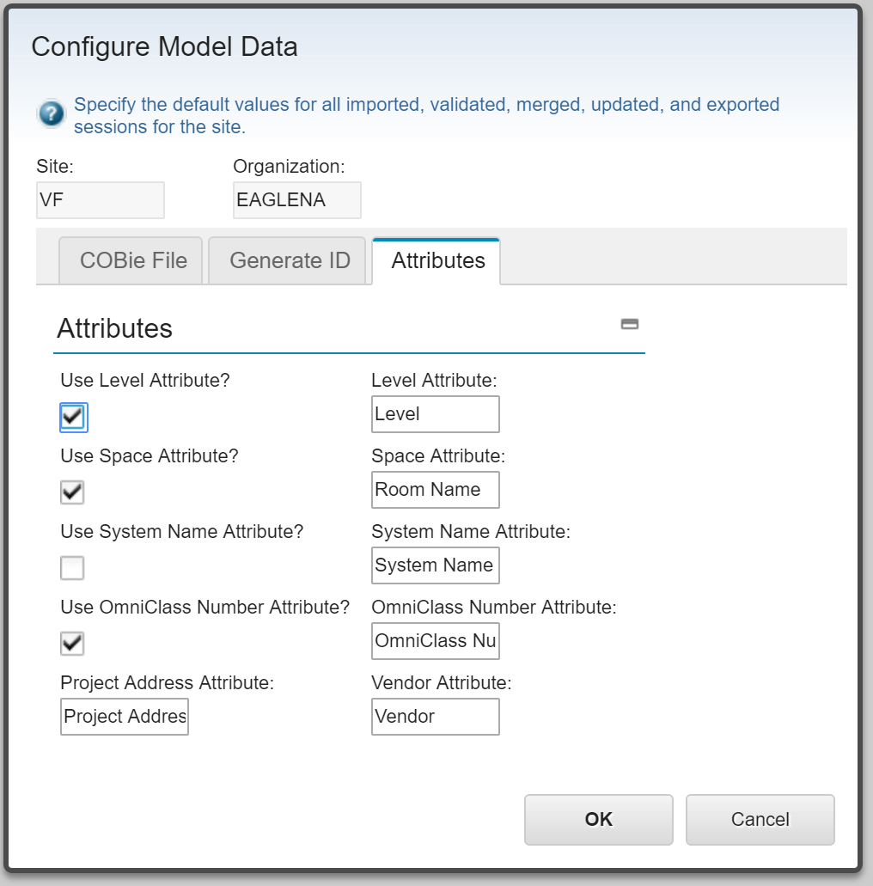

Figure - Import Attribute Mapping

* **Use Level Attribute:** If this option is selected, and an attribute sheet is provided as part of the import, each item in the Space and the Component page is searched for an attribute that has a level reference. The list of attribute types associated with the import are searched in order for attributes types with the following names:
  + The value specified in the Level Attribute field
  + Level
  + Schedule Level

If any of the above are found it is assumed to be the attribute that has a level reference. For each component that has an instance of that attribute type, an attempt is made to resolve the value of the attribute as a floor reference. If it succeeds, and if the component does not have a valid space reference, then the component is associated with that floor.

The level reference is explicitly checked against any Floor filters and excluded or included as specified by the filter

* **Use Space Attribute:** If this option is selected, and an attribute sheet is provided as part of the import, each item in the Component page is searched for an attribute of the name provided. For each component that has an instance of that attribute type, an attempt is made to resolve the value of the attribute as a space reference. If it succeeds, and if the component does not have a valid space reference, then the component is associated with that space.
* **Use system Name Attribute**: If this option is selected, and an attribute sheet is provided as part of the import, each component is search for an attribute of the name provided. The attribute is assumed to contain a comma separated list of systems to which the component belongs. For each item in the list, the list of existing systems is searched and if a match is found, the component is added to the system. If no march is found, a new system is created with the component as its first member.
* **Use OmniClass Number Attribute:** If this option is selected, and an attribute sheet is provided as part of the import, each item in it that has a category value (Facility, Floor, Space, System, Zone, and Type) is searched for an attribute that matches the value of the OmniClass number. If the category field is blank, it is set to the value of the attribute. No validation is done that it is a valid OmniClass number so this mechanism can be used with any classification scheme.
* **Project Address Attribute:** If the facility has an attribute that matches the name listed here, and the value of the attribute is a valid address, the import creates a Service Address record for the address and associates it with the location created for the facility. The Revit COBie toolkit typically creates an attribute named “Project Address” from the address contained in the model project information.
* **Vendor Attribute:** The vendor attribute provides a mechanism to populate the vendor field of Maximo asset records created from COBie components. If the component has an attribute that matches the name in this field, the import attempts to resolve its value to a Maximo company and populate the asset vendor field with the resulting Company ID. To resolve the value to a Company it must be one of:

### Configure Maximo Data

To set the Maximo data options for a site: from the main tab of the import applications:

Select Action->Configuration Import Data->Configure Maximo Data

The Configure Maximo Data dialog is displayed for the site of the import project.

#### Maximo Record Creation

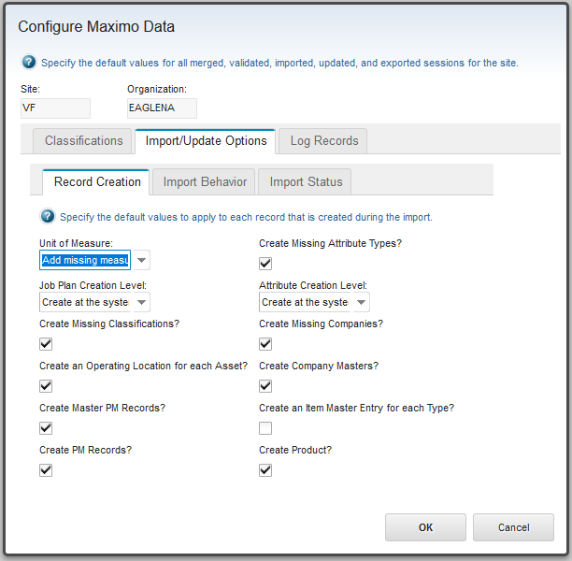

Figure – Upload dialog options tab – What to create

* **Units of measure import behavior:** Maximo expects all units of measure referenced by any application to be defined in the “Units of Measure table”. The import utility provides three options for handling units of measure encountered during the import:
  + **Do not validate measurement units on import:** Units are not checked against the Unit of Measure table. This may result in units without valid references. This is not recommended unless there is an expectation that units will be manually review after import
  + **Add Missing measurement units on import:** Missing units are automatically added to the Units of Measure table. This is a good option if the model is clean.
  + **Validate measurement units on import:** All units of measure are check against the Units of Measure table. Warnings are issued when units are encountered that are not in the table. Unit fields that don’t have valid references are not set.
* **Create Missing Classification**: Selection this option causes COBie categories that don’t match existing Maximo classifications to be added. New classifications are created as children of the default classification for the referenced object type in the Import Configuration for the site. If no default is supplies, the classification is not added and the missing classification is not reported. It also allows the Use With list to be update for existing classifications to allow an existing classification to be used in the context in which it is found by the import
* **Create an Operating Location for each Asset**: By default, the Model import and the model visualization use a Maximo concept known as operation locations.

This creates a location for every asset. This behavior may be turned off. Doing so disables or limits the following:

* + COBie types cannot be imported as design specifications
  + COBie Systems cannot be imported
  + The viewer on the Work Order Tracking application can only show locations
* **Create Master PM records**: If this option is selected, for each Job of type Preventive Maintenance (PM), a Master PM record is created and associated with the Product the Job references.
* **Create PM records**: If this option is selected and Create Master PM records is also selected, For every asset that is an instance of the Product and for which a Master PM record was created,, a PM record is created linking the asset to the Master PM record.
* **Create missing attribute types**: If this option is not selected, then only attribute with names and data types that match attribute types that are predefined in Maximo are imported. All other attributes are skipped. Maximo attribute types are defined at:

Goto->Administration->Classifications

=> Select Actions->Add/Modify Properties->Attributes

If this option is checked, Attribute Type definitions are added as needed and all attribute not otherwise filtered are imported.

* **Create missing Companies:** If this option is selected and Contacts are imported as Companies, Company and Company Contact records are created as needed. If this option is not selected, no new Company or Company Contact records are created. However, if Contacts are imported as Companies, it improves the options for matching against existing Companies.
* **Create Company Masters**: The Maximo Company registry has 2 levels: Company Masters which belong to Company sets and Companies which belong to Organizations. Every Company must have a Company Master. Company sets have an option to automatically create Company Masters if a Company is added to an Organization and no Company Master exists. If that option is not selected, then the import cannot create Companies for which no Company master exists. Selecting this option allows the import to also create Company Masters if needed.
* **Create an Item Master Entry for each Type**: If this option is selected, and Item Master entry is created for each COBie type and linked to the product created for the type. The Create Product option must also be selected.
* **Create Product**: If this option is not selected, no Product records are created. However, Type attributes and Documents can still be copied to asset that are created from Components that reference the Type.

**Site, Organization, or System Level**

Attribute Types and Job Plans are both variable level objects meaning that the Organization and Site field are optional. If either of these fields is set, then visibility of these objects for other records is limited to records that have the same value. If organization is set the it is only visible to records that have the same origination and users that have rights to the origination. Similarly, for site.

There are three options:

* Create at the system level
* Create at the organization level
* Create at the site level
* **Attribute Creation Level**: If attributes are imported, attribute types definitions can be automatically generated (See section 2.2.1). This option determines if they have origination or site values set.
* **Job Plan Creation Level**: This option determines if Job Plans have origination or site values set.

#### Import Behavior

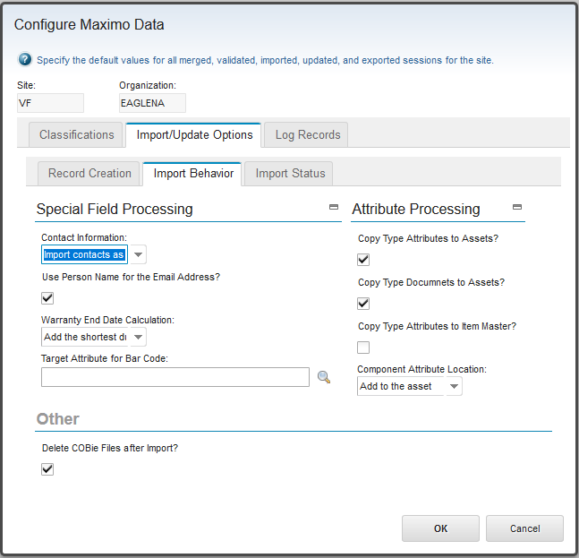

Figure – Upload dialog options tab – Import Behavior

**Special Field Processing**

* **Contact Information**: COBie contact information may be mapped to either or both of the Maximo Person record or the Maximo Company and Company Contact records. The import utility analyzes the contact data to determine how it is referenced.
  + **Import contacts as person records:** Contacts are imported only as Maximo Person records. References in the product record will fail because they reference Company Contacts
  + **Import contacts as company and company contacts records:** Contacts are imported only as Company/Company Contact. References to Contacts as created by will fail because they reference Persons
  + **Import contacts as person and company records:** All Contacts are imported as Maximo Person and Company/Company Contact records
  + **Import contacts as used:** Contacts are imported as Maximo Person records, Maximo Company/Company Contact records, or both based on how they are referenced.
* **Use person name for the email address:** The COBie specification expects the contact name to be a valid email address. If Contacts are imported as Maximo Persons. The COBie contact name is used as the Person Name value. If this box is checked, it is also used as the person’s primary email. Some basic validation is performed to ensure that it is a valid email.
* **Warranty end date calculation**: Maximo assets track warranty end date, but COBie specifies warranty duration. This option controls how the warranty end date is calculated from the asset install data and the COBie warranty data. COBie specifies two warranty durations: one for parts and one for labor. If an asset has a valid install date the warranty end data is calculated by adding the selected value to the install date.
* **Target attribute for bar code:** The COBie bar code field can be copied to any attribute in the Asset record. The lookup dialog associated with this field provides a reasonable set of options and should display user defined fields. It uses the following query:

objectname = 'ASSET' and ( maxtype = 'UPPER' OR maxtype = 'ALN' ) and LOCALIZABLE = 0 and RESTRICTED = 0 and DOMAINID is NULL and PERSISTENT = 1 and SAMEASOBJECT is null and ATTRIBUTENAME <> 'ASSETNUM'  
Values not appearing in the lookup dialog may be manually entered

**Warning:** Care should be taken in using this field as populating fields defined and used by other applications or integrations could cause them to behave unpredictability.

**Attribute Processing**

* **Copy type attributes to assets**: If this box is checked, attributes that reference a COBie type are copied to every asset created from a Component that references the type.
* **Copy type documents to assets**: If this box is checked, documents that reference a COBie type are copied to every asset created from a Component that references the type.
* **Copy type attributes to Item master:** If this box is checked and the “Create an Item Master Entry for each Type” option on the Record Creation tab is also selected, attributes that reference a COBie type are copied to the Item Master created for the type. Otherwise they are only added to the product created for the type.
* **Component attribute location:** Determines if attributes associated with COBie components are added as specifications to the Maximo operating location created for the component, the asset created for the component or both
* **Logging level (On Log Records tab):** Controls the amount of logging information that is stored with the session record in the database and reported on the Log Records tab.

#### Import Status

Many Maximo records have a status associate with them that determines their behavior in various contexts. The import can create records in a valid status for the object type. It supersedes come business rules allowing objects to be related to each other when they are in a state that doesn’t normally allow the relationship to be created. The intent of this is to allow a fully defined facility to be imported in “Imported” and “Draft” and be reviewed before it is moved to “Active” state.

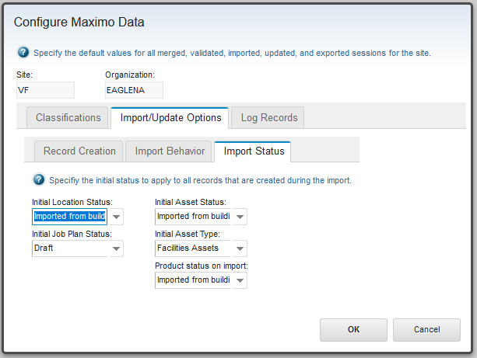

* **Asset status on import:** Sets the initial Maximo status of all asset records created by the imports.
* **Asset type on import:** Sets the initial type of all asset records created by the imports.
* **Location status on import:** Sets the initial Maximo status of all location records created by the imports.
* **Product status on import:** Sets the initial Maximo status of all product records created by the imports.
* **Job Plan status on import:** Sets the initial Maximo status of all job plan records created by the imports.

## Building commissioning

The Facility commissioning tool provides a bulk status update for all object with status related to a facility. It is intended to be used to move a facility from the status used for import into production. It uses the same algorithm to find members of the facility described under 2.3.6 Export Sessions with the addition of PM records.

To launch the facility commissioning tools: on the Main tab of the building model import/export application: Select Action -> Commission Building.

There is also a history table to view past commissioning activity and the status of any running processes.

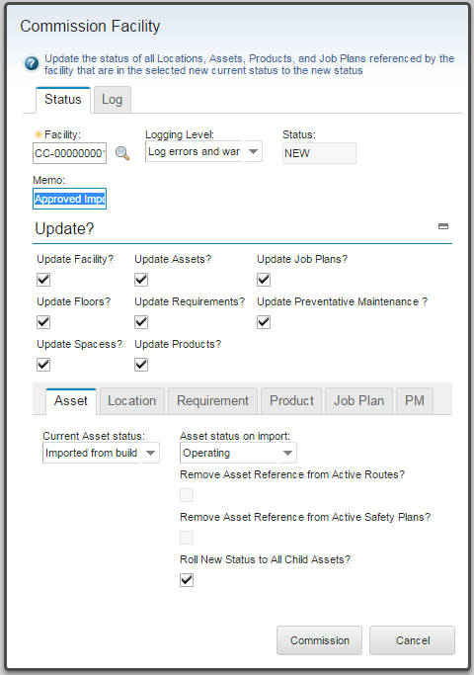

Figure – Facility Commissioning tool

* **Facility**: A facility created by an import session in this project, and the root locations for all searches for items whose status is to be updated.
* **Logging level:** Controls the amount of logging information that is stored with the session record in the database and reported on the Log Record tab.
* **Memo:** The memo field for the status change. The same memo is used for all updates.
* **Update?:** The set of types of objects to be included in the status update
* **Current <object> Status:** Only objects of the given type that currently have this status are selected for update. The current status can be different for each object type.
* **New <Object> Status:** The status for objects of the given type after commissioning. It must be a valid status transition for that object type

Location and Asset have additional fields that are only valid for some status transitions. These are the same fields that are in the Change Status dialogs for these applications.

# Product Application and other Extensions

## The Product Application (ISM Only)

The Product application provides for import and management of the data contain in the COBie Type table. This application contains product descriptions for the assets created by the import and may be used to create additional product definitions for any asset. It is intended to support a product catalog implemented in Maximo. A product defines a specific item offered by a manufacturer. It is typically described by a combination of manufacture or company and model number. An asset may reference a single product, and many assets may reference the same product.

The Product application is launched from the Building Information Models menu.

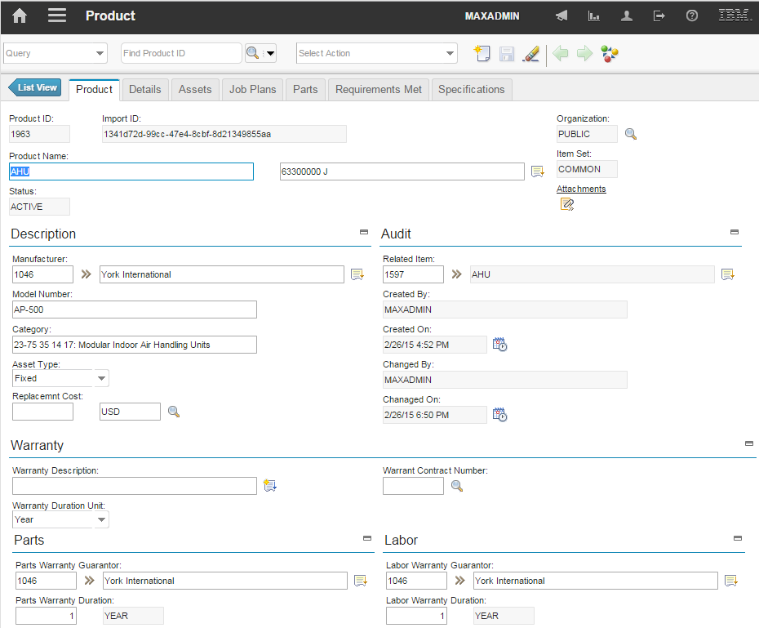

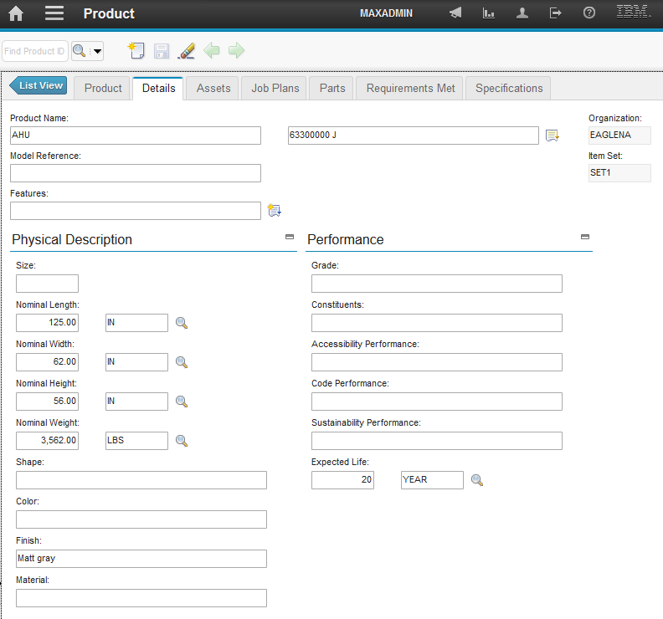

The product associated with an asset may also be viewed from the asset select actions menu

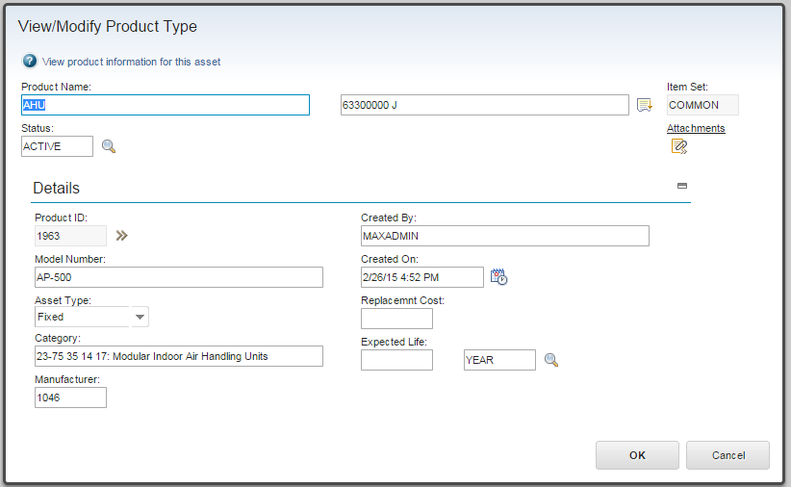 There is also a product tab added to the company application which contains a list of all product manufactured by the company.

## The Design Specification Application (ISM Only)

The Design Specification application is s subclass of the product application. It is intended to track the original design specification for an operating location for use in maintenance and replacement of failed equipment. Design specifications are linked to one or more locations. When created by the import they are linked to the operating location created for the COBie Component that references the COBie Type from which the specification is derived.

Subsequent COBie updates can link Product record to the Design Specifications they meet. This is done by matching the COBie ExteranlIdentifier. In a more realistic scenario, COBie types are imported as Design Specifications, then are manually linked to Products from a product catalog that meet the specification, possible in support of the bid process.

Design Specifications support threaded comments for design review.

## Other Extensions

### Viewing Import information

From any location or asset that was created via the COBie import, it is possible to view the import sessions for the parent facility. This includes project information and settings that apply to the entire facility such as the units of measure.

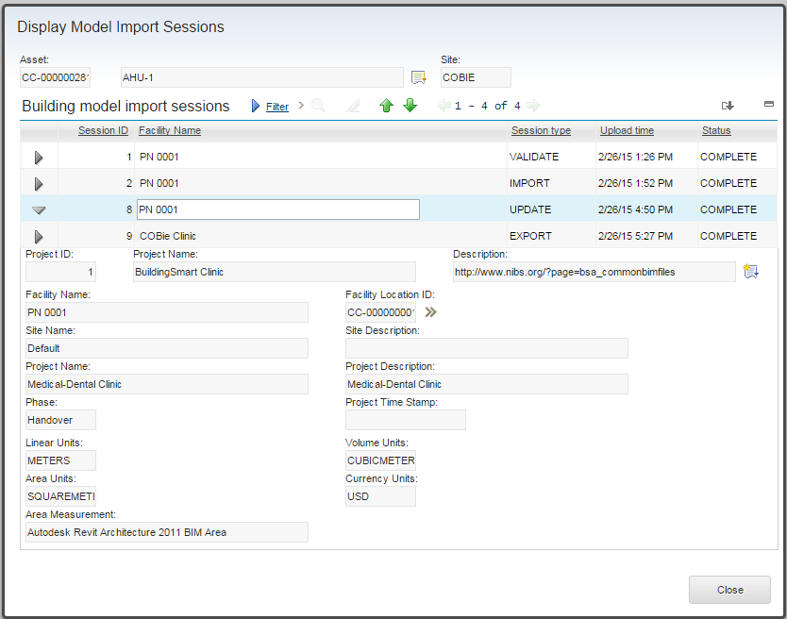

### Inspect Asset Details

This dialog is available from any locations by selecting Select Action->Inspect Asset Details. It provides a filterable list of all assets contained within the location. That is, any asset that is associated with the location, or any child location. When this dialog is displayed from the viewer, it can highlight the result set in the viewer.

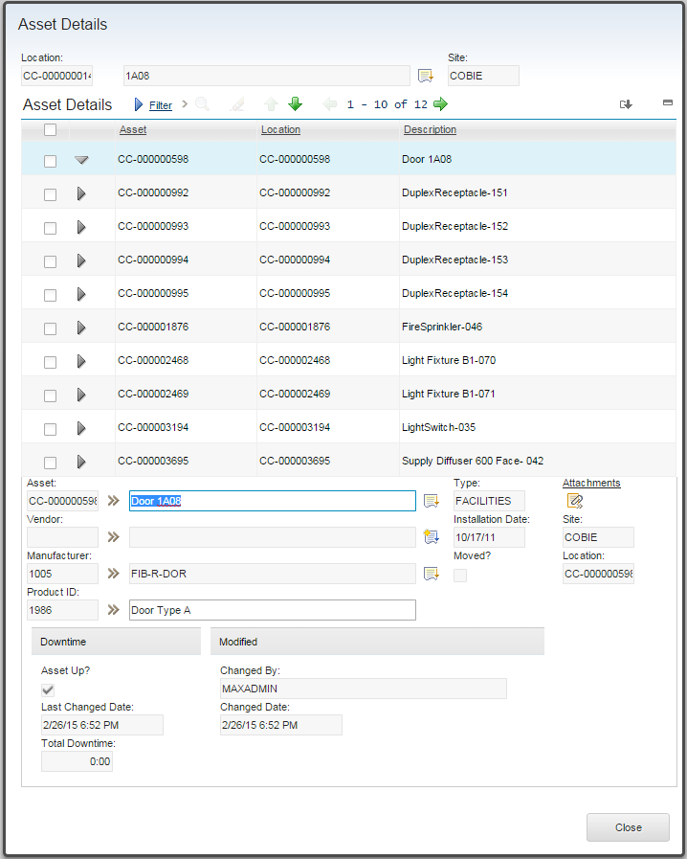

### Display System Details

This dialog is available for any locations by selecting Select Actions->Display System Details. It displays a list of all systems of which the location is a member except the primary system, and provides a tree view of the system and access to attachments and classifications for systems. If this dialog is launched from the viewer, either all or a single member of the system may be displayed in the viewer.

### Other Extensions

* A set of BIM specific fields are added to location
* The Asset Status domain has the “Imported” status added
* The Person table is classified.
* The System table is classified
* Attachments are added to Systems
* The Company table adds a list of product manufactured by the company
* Company Contact is classified

# Security

The Maximo extensions for buildings add several signature options. Security groups must be updated to grant access to these options. By default, they are only granted to the MAXADMIN security group. To change security options:

* Goto->Security->Security Groups
* Search for the security group to which you wish grant rights
* Selection the application tab
* Search for the Building Model Import application
* Grant rights as desired
* Save your changes

## BIM Specific Signature Options

|  |  |  |  |
| --- | --- | --- | --- |
| Name | Rights | Group | Description |
| Start Center | | | |
| *READ* | *READ, CLEAR* |  | *Read Access to Import Project* |
| BIM Project | | | |
| *BIM_CONFIG* | *READ* |  | *Configure Maximo Data* |
| *MDL_CONFIG* | *READ* |  | *Configure Model Data* |
| *BIM_FILTER* | *READ* |  | *Import Filters* |
| *BIM_MAP* | *READ* |  | *Map to Fields* |
| *TYPE_MAP* | *READ* |  | *Map Attributes to Specifications* |
| *OMNI_ADD* | *READ* |  | *OmniClass Import* |
| *UNI_ADD* | *READ* |  | *Uniformat Import* |
| *OMNI_HIST* | *READ* |  | *Classification Import History* |
| *COMMISSION* | *READ* |  | *Commission Building* |
| *COMS_HIST* | *READ* |  | *Building Commissioning History* |
| MEASUNIT | READ |  | Units of Measure |
| *BIM_ADVANCED_OPT* |  |  | *Advanced Options tab in upload dialog* |
| Location | | | |
| *BIMDATA* |  |  | *Show BIM Data sections* |
| *BIMVIEWER* |  |  | *BIM viewer tab* |
| *BIM_ADDMOD* |  |  | *Add/Edit Building Model* |
| *BIM_IMP* | *READ* |  | *View Building Model Import Sessions* |
| *BIM_IAD* | *READ* |  | *Inspect Asset Details* |
| *BIM_DS* | *READ* |  | *Display System Details* |
| *BIM_US* |  |  | *Update/Edit Systems* |
| *BIM_NS* |  |  | *Create New System* |
| Asset | | | |
| *BIMDATA* |  |  | *Show BIM Data sections* |
| *BIMVIEWER* |  |  | *BIM viewer tab* |
| *BIM_IMP* | *READ* |  | *View Building Model Import Sessions* |
| *BIM_VPT* |  |  | *View Product for Asset* |
| Company | | | |
| *BIM_PRDCT* |  |  | *View Products for Company* |
| Create Service Request | | | |
| *BIMLOOKUP* |  |  | *BIM viewer lookup for assets* |
| Work Order Tracking | | | |
| *BIMLOOKUP* |  |  | *BIM viewer lookup for assets* |
| *BIMVIEWER* |  |  | *BIM viewer tab* |

## Conditional UI

There are several BIM UI elements that are controlled by conditional expressions

#### BIM Data in the Locations application

There are three fields added to the locations application for BIM data. These are contained in a section on the main page of the locations application. The section is displayed if the location is a Floor or Space created by COBie import



Signature Options:

BIMDATA

Condition Name:

BIMDATA

Condition Expression:

:bimusage in ( select value from synonymdomain where domainid ='BIMLOCATIONUSE' and (MAXVALUE = 'SPACE' or MAXVALUE ='FLOOR' or MAXVALUE ='FACILITY' ))

#### Building location in Assets Application

When operating locations are used, the location field on an asset is typically not very useful. Therefor if the asset was created via BIM import, a Facility, Floor, and Space field are displayed for the asset. These sections are displayed if the asset is contained within a facility created by a COBie import

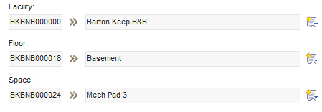

Signature Options:

BIMBIMDATA

Condition Name:

BIM_LOC

Condition Expression:

exists( select * from locations where :location in ( select ancestor from locancestor where systemid in ( select systemid from locsystem where siteid =:siteid and primarysystem = 1)) and BIMUSAGE in ( select value from synonymdomain where domainid = 'BIMLOCATIONUSE' and MAXVALUE = 'FACILITY' ) )

#### Import History

The Locations and the Assets application both have an option on the select actions menu to display the import history of a record. This option is only displayed if the record has an import history. For the Locations application it is controlled by the BIMDATA condition (See above) for the Assets application it is controlled by:

Signature Options:

BIM_IMP

Condition Name:

BIM_IMP

Condition Expression:

exists( select facility from bimsession where facility in (select ancestor from locancestor where location =:location and siteid =:siteid and systemid in ( select systemid from locsystem where siteid =:siteid and primarysystem = 1 )))

#### 3D View Tab

The 3D View tab which appears on the Locations, Assets, and Work Order Tracking application is only displayed if there is a viewer installed and active. The condition is based on the value of the system property ''bim.viewer.active'. If its value is anything other than ''vendor'” the tabs are displayed.

Signature Options:

BIMVIEWER

Condition Name:

BIMVIEWER

Condition Expression:

exists ( select * from maxpropvalue where propname='bim.viewer.active' and (propvalue <> 'vendor' and propvalue is not null ))

# Trouble Shooting

You can find further information on our forum located at <http://www.ibm.com/developerworks/forums/forum.jspa?forumID=2981>

## Import

**Symptom:** Error BMXAA0311E - Companies for this organization must be added through the Company Master application

* Insure that the “Automatically Add Companies to Company Master?” box is check for the Company set for the organization or select “Create Company Master” on the Configure Maximo Dara dialog.

**Symptom:** After upgrading Maximo, importing s spread sheet fails with a null pointer exception, InvocationTarget exception of ClassNotFound exception.

* The upgrade process overwrites he changes to builldmaximoear.xml this steps need to be repeated and the .EAR file redeployed.

**Symptom:** An import Update or Export session has failed leaving the session in a running state.

* This typically only happens due to a server crash while a session is running, such as from an out of memory error. On server startup, a cleanup thread runs which should set the session to a FAILED status. It is also possible to use a database tool to set the value of the STATUS column in the BIMSESSION table to FIALED.

**Symptom:** An import reports 'Error: org.apache.poi.ss.usermodel.Workbook

* When the BIM solution was installed, either buildmaximoear.xml was not modified or the Apache Poi jars were incorrectly specified.

**Symptom:** Error: Exception: SYSTEM, <Value> - BMXAA4049E - The value specified DIGITAL CONTROL exceeds the maximum field length 12. Enter a value that fits into the length of this attribute.

* The SystemId field in the LocSystem table has been increased in length, but the SystemId field in the location object has not been increased to the same length

# COBie to MAXIMO Field Mapping

## Contact

COBie contacts can be mapped to either PERSON or COMPANIES and COMPANY CONACT or both. The import process tracks how a contact is referenced. If it is referenced on COBie a createdBy field, than it is a candidate for PERSON, otherwise it is a candidate for COMPANIES

### As Person

|  |  |  |  |
| --- | --- | --- | --- |
| **COBie Field** | **Maximo Field** | **Update?** | **Notes:** |
| **Email** | *PERSONID/ PRIMARYEMAIL* | No/Yes | For *PRIMARYEMAIL* there is import control and it must be a valid internet email address format |
| **CreatedBy** | -- Not Mapped -- |  | Set to current user on export |
| **CreatedOn** | -- Not Mapped -- |  | Timestamp on Export |
| **Category** | *CLASSSTRUCTUREID* | Yes | May create classifications |
| **Company** | -- Not Mapped -- |  |  |
| **Phone** | *PRIMARYPHONE* | Yes |  |
| **ExternalSystem** | -- Not Mapped -- |  | Set to Maximo Server Name on export |
| **ExternalObject** | -- Not Mapped -- |  | Set to PERSON on export |
| **ExternalIdentifier** | -- Not Mapped -- |  |  |
| **Department** | *DEPARTMENT* | Yes |  |
| **OrganizationCode** | -- Not Mapped -- |  |  |
| **GivenName** | *FIRSTNAME* | Yes | GivenName and Family name are concatenated for Display Name |
| **FamilyName** | *LASTNAME*-- | Yes |  |
| **Street** | *ADDRESSLINE1* | Yes |  |
| **PostalBox** | *LASTNAME* | Yes |  |
| **Town** | *CITY* | Yes |  |
| **StateRegion** | *STATEPROVINCE* | Yes |  |
| **PostalCode** | *POSTALCODE* | Yes |  |
| **Country** | *COUNTRY* | Yes |  |

### As Company and Company Contact

Contacts that are reference from the type table are mapped to COMPANIES and COMPCONTACT. All contacts that share the same company are grouped as COMPCONTACT records under a single COMPANIES record. The first contact encountered is arbitrarily selected as the primary contact

|  |  |  |  |
| --- | --- | --- | --- |
| **COBie Field** | **Maximo Field** | **Update?** | **Notes:** |
| **Email** | *EMAIL* | No | Must be a valid internet email address format |
| **CreatedBy** | -- Not Mapped -- |  | Set to current user on export |
| **CreatedOn** | -- Not Mapped -- |  | Timestamp on Export |
| **Category** | *CLASSSTRUCTUREID* | Yes | COMPCONTACT |
| **Company** | *NAME* | No | COMPANIES |
| **Phone** | *VOICEPHONE, PHONE* | No | COMPCONTACT/COMPANIES from primary contact |
| **ExternalSystem** | -- Not Mapped -- |  | Set to Maximo Server Name on export |
| **ExternalObject** | -- Not Mapped -- |  | Set to PERSON on export |
| **ExternalIdentifier** | -- Not Mapped -- |  |  |
| **Department** |  |  |  |
| **OrganizationCode** |  |  |  |
| **GivenName** | *CONTACT* | No | Concatinated together |
| **FamilyName** | No |
| **Street** | *ADDRESS1* | No | COMPANIES from primary contact |
| **PostalBox** | *ADDRESS1* | No | COMPANIES from primary contact, Only if street is blank |
| **Town** | *ADDRESS2* | No | COMPANIES from primary contact |
| **StateRegion** | *ADDRESS3* | No | COMPANIES from primary contact |
| **PostalCode** | *ADDRESS4* | No | COMPANIES from primary contact |
| **Country** | *ADDRESS5* | No | COMPANIES from primary contact |

## Facility

The COBie Facility table is mapped to the Maximo Location table. Additional values from the Facility are stored in the import session

|  |  |  |  |
| --- | --- | --- | --- |
| **COBie Field** | **Maximo Field** | **Update?** | **Notes:** |
| **Name** | *DESCRIPTION / FACILITYNAME* | Yes | Also Long Description/Import Session |
| **CreatedBy** | -- Not Mapped -- | No | Set to current user on export |
| **CreatedOn** | -- Not Mapped -- | No | Timestamp on Export |
| **Category** | *CLASSSTRUCTUREID* | Yes | May create classifications |
| **ProjectName** | *PROJECTNAME* | No | Import Session |
| **SiteName** | *SITENAME* | No | Import Session |
| **LinearUnits** | *BIMLINEARUNITS/ LINEARUNITS* | Yes/No | LOCATIONS/Import Session, Any object using linear units. May also be added to the MEASUREUNIT table |
| **AreaUnits** | *BIMAREAUNITS/ AREAUNITS* | Yes | LOCATIONS/Import Session, , Any object using area units. May also be added to the MEASUREUNIT table |
| **VolumeUnits** | *VOLUMEUNITS* | No | Import Session, Any object using volume units. May also be added to the MEASUREUNIT table |
| **CurrencyUnit** | *CURRENCYCODE* | No | Import Session, Any object using currency. May also be added to the CURENCY table |
| **AreaMeasurement** | *AREAMEASURMENT* | No | Import Session |
| **ExternalSystem** | -- Not Mapped -- |  |  |
| **ExternalProjectObject** | -- Not Mapped -- |  |  |
| **ExternalProjectIdentifier** | -- Not Mapped -- |  |  |
| **ExternalSiteObject** | -- Not Mapped -- |  |  |
| **ExternalSiteIdentifier** | -- Not Mapped -- |  |  |
| **ExternalFacilityObject** | -- Not Mapped -- |  |  |
| **ExternalFacilityIdentifier** | *MODELID* | No |  |
| **Description** | *LONG_DESCRIPTION* | Yes |  |
| **ProjectDescription** | *PROJECTDESC* | No | Import Session |
| **SiteDescription** | *SITEDESC* | No | Import Session |
| **Phase** | *PHASE* | No | Import Session |

## Floor

The COBie Floor table is mapped to Maximo LOCATIONS. All LOCATION records created from COBie Floors have the facility location as their parent.

|  |  |  |  |
| --- | --- | --- | --- |
| **COBie Field** | **Maximo Field** | **Update?** | **Notes:** |
| **Name** | *DESCRIPTION* | Yes |  |
| **CreatedBy** | -- Not Mapped -- | No | Set to current user on export |
| **CreatedOn** | -- Not Mapped -- | No | Timestamp on Export |
| **Category** | *CLASSSTRUCTUREID* | Yes | May create classifications |
| ExtSystem | -- Not Mapped -- |  | Set to Maximo Server Name on export |
| ExtObject | -- Not Mapped -- |  | Set to LOCATIONS on export |
| ExtIdentifier | *MODELID* | No |  |
| **Description** | *LONG_DESCRIPTION* | Yes |  |
| Elevation | *BIMELEVATION* | Yes |  |
| Height | *BIMHEIGHT* | Yes |  |

## Space

The COBie Space table is mapped to Maximo LOCATIONS

|  |  |  |  |
| --- | --- | --- | --- |
| **COBie Field** | **Maximo Field** | **Update?** | **Notes:** |
| Name | *DESCRIPTION* | Yes |  |
| CreatedBy | -- Not Mapped -- | No | Set to current user on export |
| CreatedOn | -- Not Mapped -- | No | Timestamp on Export |
| Category | *CLASSSTRUCTUREID* | Yes | May create classifications |
| FloorName | *PARENT* | No | In the primary system |
| ExtSystem | -- Not Mapped -- |  | Set to Maximo Server Name on export |
| ExtObject | -- Not Mapped -- |  | Set to LOCATIONS on export |
| ExtIdentifier | *MODELID* | No |  |
| Description | *LONG_DESCRIPTION* | Yes |  |
| RoomTag | *BIMROOMNAME* | Yes |  |
| UsableHeight | *BIMHEIGHT* | Yes |  |
| GrossArea | *BIMGROSSAREA* | Yes |  |
| NetArea | *BIMNETAREA* | Yes |  |

## Component

There are two Maximo records created for each COBie component. A LOCATION record and an ASSET record. The ASSET record references the LOCATION record as its locations. The LOCATION’s parent is the Space referenced by the Component if it is valid. If not it is either a Floor if one can be determined from attributes, or the Facility

|  |  |  |  |
| --- | --- | --- | --- |
| **COBie Field** | **Maximo Field** | **Update?** | **Notes:** |
| *Name* | *DESCRIPTION* | Yes, Yes | ASSET, LOCATION |
| *CreatedBy* | -- Not Mapped -- | No | Set to current user on export |
| *CreatedOn* | -- Not Mapped -- | No | Timestamp on Export |
| *TypeName* | *MANUFACTURER* |  | ASSET, Reference to BIMPRODUCT |
| *Space* | *PARENT* |  | LOCATION |
| *Description* | *LONG_DESCRIPTION* | Yes, Yes | ASSET, LOCATION |
| *Category* | *CLASSSTRUCTUREID* | Yes | Controlled by user options on where attributes are placed. |
| *ExtSystem* | -- Not Mapped -- |  | Set to Maximo Server Name on export |
| *ExtObject* | -- Not Mapped -- |  | Set to ASSET on export |
| *ExtIdentifier* | *MODELID* | No, No | ASSET, LOCATION |
| *SerialNumber* | *SERIALNUM* | Yes | ASSET |
| *InstallationDate* | *INSTALLDATE* | Yes | ASSET |
| *WarrantyStartDate* | *WARRANTYEXPDATE* | Yes | ASSET, Calculated from warrantee duration in referenced type. |
| *TagNumber* | *ASSETTAG* | Yes | ASSET |
| *BarCode* | *Configurable* | If not Key | ASSET |
| *AssetIdentifier* | -- Not Mapped -- |  |  |

## Type

The COBie Type table is mapped to the Maximo BIMPRODUCT table and may optionally also create an Item Master record for each type. Each product record has a reference to the associated ITEM record.

|  |  |  |  |  |
| --- | --- | --- | --- | --- |
| **COBie Field** | | **Maximo Field** | **Update?** | **Notes:** |
| **Name** | *NAME* | | Yes |  |
| **CreatedBy** | -- Not Mapped -- | | No | Set to current user on export |
| **CreatedOn** | *CREATEDON* | | Yes | Timestamp on Export |
| **Description** | *LONG_DESCRIPTION* | | Yes |  |
| **Category** | *CLASSSTRUCTUREID, CATEGORY* | | Yes | May cause classification to be created. |
| **AssetType** | *BIMASSETTYPE* | | Yes |  |
| **Manufacturer** | *MANUFACTURER* | | Yes | Reference to COMPANIES |
| **ModelNumber** | *MODELNUMBER* | | Yes |  |
| **WarrantyGuarantorParts** | *PARTSWARRANTYGUARANTOR* | | Yes | Reference to COMPANIES |
| **WarrantyDurationParts** | *PARTSWARRANTDURATION* | | Yes |  |
| **WarrantyGuarantorLabor** | *LABORWARRANTYGUARANTOR* | | Yes | Reference to COMPANIES |
| **WarrantyDurationLabor** | *LABORWARRANTYDURATION* | | Yes |  |
| **WarrantyDurationUnit** | *WARRANTYDURATIONUNIT* | | Yes |  |
| **ExtSystem** | -- Not Mapped -- | |  | Set to Maximo Server Name on export |
| **ExtObject** | -- Not Mapped -- | |  | Set to BIMPRODUCT on export |
| **ExtIdentifier** | *MODELID* | | No |  |
| **ReplacementCost** | *REPLACEMENTCOST* | | Yes |  |
| **ExpectedLife** | *EXPECTEDLIFE* | | Yes |  |
| **DurationUnit** | *DURATIONUNIT* | | Yes |  |
| **WarrantyDescription** | *WARRANTYDESC* | | Yes |  |
| **NominalLength** | *NOMINALLENGTH* | | Yes |  |
| **NominalWidth** | *NOMINALWIDTH* | | Yes |  |
| **NominalHeight** | *NOMINALHEIGHT* | | Yes |  |
| **ModelReference** | *MODELREFERENCE* | | Yes |  |
| **Shape** | *SHAPE* | | Yes |  |
| **Size** | *PRODUCTSIZE* | | Yes |  |
| **Color** | *COLOR* | | Yes |  |
| **Finish** | *FINISH* | | Yes |  |
| **Grade** | *GRADE* | | Yes |  |
| **Material** | *MATERIAL* | | Yes |  |
| **Constituents** | *CONSTITUENTS* | | Yes |  |
| **Features** | *FEATURES* | | Yes |  |
| **AccessibilityPerformance** | *ACCESSIBILITYPERFORMANCE* | | Yes |  |
| **CodePerformance** | *CODEPERFORMANCE* | | Yes |  |
| **SustainabilityPerformance** | *SUSTAINABILITYPERFORMANCE* | | Yes |  |

Mapping of COBie Type to Item Master

|  |  |  |  |  |
| --- | --- | --- | --- | --- |
| **COBie Field** | | **Maximo Field** | **Update?** | **Notes:** |
| **Name** | *NAME* | | No |  |
| **Description** | *LONG_DESCRIPTION* | | No |  |
| **Category** | *CLASSSTRUCTUREID, CATEGORY* | | No | May cause classification to be created. |

## Zone

COBie Zones are mapped to the Maximo LOCSYSTEM table with accompanying LOCANCESTOR and LOCHIERARCHY records. A LOCSYSTEM record is created for each zone. The system is hierarchical with the facility LOCATION as the root of the system and each space as a child of the facility.

|  |  |  |  |
| --- | --- | --- | --- |
| **COBie Field** | **Maximo Field** | **Update?** | **Notes:** |
| *Name* | *DESCRIPTION* | Yes, No | ASSET, LOCATION |
| *CreatedBy* | -- Not Mapped -- | No | Set to current user on export |
| *CreatedOn* | -- Not Mapped -- | No | Timestamp on Export |
| *Category* | *CLASSSTRUCTUREID* | Yes | May cause classification entries to be created. |
| SpaceNames | *Member of System* | Yes |  |
| *ExtSystem* | -- Not Mapped -- |  | Set to Maximo Server Name on export |
| *ExtObject* | -- Not Mapped -- |  | Set to LOCSYSTEM on export |
| *ExtIdentifier* | *MODELID* | No, No | ASSET, LOCATION |
| *Description* | *LONG_DESCRIPTION* | Yes, No | ASSET, LOCATION |

## System

COBie Systems are mapped to the Maximo LOCSYSTEM table with accompanying LOCANCESTOR and LOCHIERARCHY records. A LOCSYSTEM record is created for each zone. The system is hierarchical with the facility LOCATION as the root of the system and the operating location associated with each component as a child of the facility.

|  |  |  |  |
| --- | --- | --- | --- |
| **COBie Field** | **Maximo Field** | **Update?** | **Notes:** |
| *Name* | *DESCRIPTION* | Yes, No | ASSET, LOCATION |
| *CreatedBy* | -- Not Mapped -- | No | Set to current user on export |
| *CreatedOn* | -- Not Mapped -- | No | Timestamp on Export |
| *Category* | *CLASSSTRUCTUREID* | Yes | May cause classification entries to be created. |
| SpaceNames | *Member of System* | Yes | Reference operating location |
| *ExtSystem* | -- Not Mapped -- |  | Set to Maximo Server Name on export |
| *ExtObject* | -- Not Mapped -- |  | Set to LOCSYSTEM on export |
| *ExtIdentifier* | *MODELID* | No, No | ASSET, LOCATION |
| *Description* | *LONG_DESCRIPTION* | Yes, No | ASSET, LOCATION |

## Job

The COBie Job table is mapped to the Maximo JOBPLAN and JOBTASK tables. One or more BIMPRODUCTJOB records are created for each JOBPLAN to associate it with the product is applies to. If the Job is of type Preventative Maintenance, a MASTERPM record is also created with a reference to the JOBPLAN, and a PM record is created to associate every Component the reference a type to which the Job is associated with the MASTERPM record.

JOBTASK records are created for each task defined for the Job

|  |  |  |  |
| --- | --- | --- | --- |
| **COBie Field** | **Maximo Field** | **Update?** | **Notes:** |
| *Name* | *DESCRIPTION* | No | JONPLAN, MASTERPM |
| *CreatedBy* | -- Not Mapped -- | No | Set to current user on export |
| *CreatedOn* | -- Not Mapped -- | No | Timestamp on Export |
| *Category* | *CLASSSTRUCTUREID, JOBTYPE* | No | JOBPLAN, BIMPRODUCTJOB, May cause classification entries to be created.  If the Category is “PM” Master PM and PM records are created |
| Status | -- Not Mapped -- |  |  |
| TypeName | *BIMPRODUCTJOB* | No | Many-to-Many relationship |
| *Description* | *LONG_DESCRIPTION* | No | JONPLAN, MASTERPM |
| Duration | *JPDURATION, TASKDURATION* |  | JOBPLAN, JOBTASK, Normalized to hours |
| DurationUnit | -- Not Mapped -- |  |  |
| Start | *MNEXTDATE* |  | MASTERPM |
| TaskStartUnit | -- Not Mapped -- |  |  |
| Frequency | *FREQUENCY* |  | MASTERPM |
| FrequencyUnit | *FREQUNIT* |  | MASTERPM |
| *ExtSystem* | -- Not Mapped -- |  | Set to Maximo Server Name on export |
| *ExtObject* | -- Not Mapped -- |  | Set to JOBPLAN on export |
| *ExtIdentifier* | *MODELID* | No |  |
| TaskNumber | -- Not Mapped -- |  | Used to sequence tasks |
| Priors | -- Not Mapped -- |  |  |
| ResourceNames | -- Not Mapped -- |  |  |

## Attributes

The COBie attribute table is mapped to many Maximo tables. First the attributes are grouped by name to create attribute types. Then Attribute values are added as specifications to the appropriate specification table. Attributes can be added to the following table types:

* Asset (Components and optionally Types)
* Item (Types)
* Job Plan (Jobs)
* Location (Facilities, Floors, Spaces, and optionally Components)
* Product (Types)

There is a mechanism to specify default classifications to insure that every object that can have specifications is classified.

|  |  |  |  |
| --- | --- | --- | --- |
| **COBie Field** | **Maximo Field** | **Update?** | **Notes:** |
| **Name** | *DESCRIPTION* | Yes | ASSETATTURBUTE |
| **CreatedBy** | -- Not Mapped -- | No | Set to current user on export |
| **CreatedOn** | -- Not Mapped -- | No | Timestamp on Export |
| **Category** | -- Not Mapped -- |  |  |
| **SheetName** | *Reference to Maximo object* | No |  |
| **RowName** |
| **Value** | *ALNVALUE or NUMVALUE* | Yes | ASSETSPEC or similar |
| **Unit** | *MEASUREUNITID* | Yes | ASSETATTURBUTE, ASSETSPEC or similar |
| **ExtSystem** | -- Not Mapped -- |  | Set to Maximo Server Name on export |
| **ExtObject** | -- Not Mapped -- |  |  |
| **ExtIdentifier** | -- Not Mapped -- |  |  |
| **Description** | -- Not Mapped -- |  |  |
| **AllowedValues** | -- Not Mapped -- |  |  |

## Document

The COBie Document table maps to Maximo attachments. Both DOCINFO and DOCLINK records are created. If a single document is referenced more than once, then only a single DOCINFO record is created. Reference is validated by path and name on same import, and by document checksum on matches from previous imports.

|  |  |  |  |
| --- | --- | --- | --- |
| **COBie Field** | **Maximo Field** | **Update?** | **Notes:** |
| **Name** | *DOCUMENT* | No | DOCINFO,DOCLINKS |
| **CreatedBy** | -- Not Mapped -- | No | Set to current user on export |
| **CreatedOn** | -- Not Mapped -- | No | Timestamp on Export |
| **Category** | -- Not Mapped -- |  |  |
| **ApprovalBy** | -- Not Mapped -- |  |  |
| **Stage** | -- Not Mapped -- |  |  |
| **SheetName** | *Reference to Maximo object* | No |  |
| **RowName** |
| **Directory** | *URLANME* | No |  |
| **File** |  |  |
| **ExtSystem** | -- Not Mapped -- |  | Set to Maximo Server Name on export |
| **ExtObject** | -- Not Mapped -- |  |  |
| **ExtIdentifier** | -- Not Mapped -- |  |  |
| **Description** | *DESCRIPTION* |  |  |
| **Reference** | *URLANME* | No | If it contains a valid URL |

## Spare

The usage of the Spare table in COBie is ambiguous. It can both define the list of spare parts required for a Type (product), and possible describe an actual inventor of spare part. The import only addresses the first sematics. The COBie Spare table maps to the Maximo BIMProductPart table. Product parts have a many to one relationship to BIMProduct. Only Spares that have a valid Type reference are imported.

|  |  |  |  |
| --- | --- | --- | --- |
| **COBie Field** | **Maximo Field** | **Update?** | **Notes:** |
| **Name** | *NAME* | No |  |
| **CreatedBy** | -- Not Mapped -- |  |  |
| **CreatedOn** | -- Not Mapped -- |  |  |
| **Category** | -- Not Mapped -- |  |  |
| **TypeName** | *PRODUCTID* | Yes | Relationship to Product |
| **Suppliers** |  | No | BIMProductPartSupplier – Relationship to Companies table |
| **ExtSystem** | -- Not Mapped -- |  |  |
| **ExtObject** | -- Not Mapped -- |  |  |
| **ExtIdentifier** | -- Not Mapped -- |  |  |
| **Description** | *DESCRIPTION* | No |  |
| **SetNumber** | -- Not Mapped -- |  |  |
| **PartNumber** | *PARTNUM* | No |  |

The list of parts associates with a product is updatable.

## Resource (Tool)

Only resource of type tool are imported. COBie Tool resources are mapped to the Maximo ItemTool table.

|  |  |  |  |
| --- | --- | --- | --- |
| **COBie Field** | **Maximo Field** | **Update?** | **Notes:** |
| **Name** | *DESCRIPTION* | Yes |  |
| **CreatedBy** | -- Not Mapped -- |  |  |
| **CreatedOn** | -- Not Mapped -- |  |  |
| **Category** | -- Not Mapped -- |  | Must be Tool or resource is ignored |
| **ExtSystem** | -- Not Mapped -- |  |  |
| **ExtObject** | -- Not Mapped -- |  |  |
| **ExtIdentifier** | -- Not Mapped -- |  |  |
| **Description** | *LONGDESCRIPTION* | Yes |  |

## Assembly

Sets the parent field of the Asset.

# Appendix REST API support

## Service Methods

The BIM Solution defines the following Service Methods:

#### uploadClassification

Uploads a classification file and associates it with an existing BIMOmniClassImport record. The BIMOmniClassImport must be in the NEW state

See 2.2.1 OmniClass Import

Example call:

http://192.168.196.7/maximo/oslc/service/bim?~fileName=OmniClass_11.xls&action=wsmethod:uploadClassification&~importId=3

**Parameters**:

|  |  |
| --- | --- |
| action | wsmethod:uploadClassification |
| importId | The BIMOMNICLASSIMPORTID of the existing BIMOmniClassImport record to which the file is to be associated |
| fileName | The used for the uploaded classification file on the Maximo server |

**Headers**

"content-type", "Application/octet-stream"

**Output Stream**

The content of the file to upload

**startClassificationImport**

Starts a classification import session. The BIMOmniClassImport record must already exist, be in the NEW state, and have all necessary data to run.

See 2.2.1 OmniClass Import

**Example call:**

http://192.168.196.7/maxrest/rest/mbo/bimomniclassimport?~fileType=OmniClass&~importId=3

x-http-method-override, startClassificationImport

**Parameters**:

|  |  |  |
| --- | --- | --- |
| importId | The BIMOMNICLASSIMPORTID of the existing BIMOmniClassImport record to which the file is to be associated | |
| fileType | | The type of classification to import. Valid values are: OmniClass, and UniFormat |

**uploadCOBieFile**

Uploads a COBie file and associates it with an existing BIMSession record. The BIMSession must be in the NEW state

**Example call:**

http://192.168.196.7/maximo/oslc/service/bim?~fileName=Barton%20Keep.xlsx&~fileType=EXCEL&action=wsmethod:uploadCOBieFile&~projectId=2&~sessionId=13&~siteId=VF

**Parameters**:

|  |  |
| --- | --- |
| action | wsmethod:uploadCOBieFile |
| projectId | The BIMPROJECTID of the project containing the BIMSession to which the COBie file will be added |
| sessionId | The BIMSESSIONID of the BIMSession to which the COBie file will be added |
| siteId | The site Id for the project |
| fileName | The used for the uploaded COBie file on the Maximo server |
| filetype | The type of file being uploaded. Valid values are EXCEL for a full COBie spreadsheet or a COBie sheet name for a single COBie table in CSV format |

**Headers**

"content-type", "Application/octet-stream"

**Output Stream**

The content of the file to upload

#### startSession

Starts an existing session. The session may be any type. The BIMSession record must exist, be in the NEW state, and have all necessary data to run

**Example call:**

http://192.168.196.7/maxrest/rest/mbo/bimsession?~projectId=2&~sessionId=14&~siteId=VF

x-http-method-override, startSession

**Parameters**:

|  |  |
| --- | --- |
| projectId | The BIMPROJECTID of the project containing the BIMSession to start |
| sessionId | The BIMSESSIONID of the BIMSession of the session to start |
| siteId | The site Id for the project |

#### startBuildingCommisioning

Starts a building commissioning session. The BIMCommission record must already exists, be in the NEW state, and have all necessary data to run.

See 2.9 Building commissioning

Example call:

http://192.168.196.7/maxrest/rest/mbo/bimcommission?~commissioningId=2&~projectId=2

x-http-method-override, startBuildingCommisioning

**Parameters**:

|  |  |
| --- | --- |
| projectId | The BIMPROJECTID of the project containing the building to be commissioned |
| commissioningId | The BIMCOMMISSIONID of the BIMCommission session to start |
|  |  |

## Object Structures

The BIM Solution defines the following Object Structures:

|  |  |  |  |
| --- | --- | --- | --- |
| Name | Description | Parent | Children |
| BIMASSETMODELS | Provide models for launch in context of BIM mobile viewer | ASSET | BUILDINGMODEL |
| MXBIMFILTER | Filters for COBie import projects  See 2.5 Import Filters | BIMFILTER | BIMFILTER |
| MXBIMLMVMODEL | Autodesk BIM360 Viewer Model definition | BIMLMVMODEL | BIMLMVMODELUPLOAD  BIMLMVMODELLINK |
| MXBIMPROJECT | BIM Import project | BIMPROJECT | BIMSESSION, BIMFILE |
| MXPRODUCT | Product application | BIMPRODUCT | BIMPRODUCTBASESPEC, BIMPRODUCTPART, BIMPRODUCTJOB |
| MXBIMASSETWO | Work order history for an Asset | ASSET | WORKORDER |

# Appendix – Summary of Database updates

Installing the extensions makes the following changes to the Maximo database:

## Tables Created:

* **BIMATTRIBUTEMAP** **–** Defines a table mapping COBIe attribute names to Maximo mbos and fields
* **BIMATTRIBUTEMAPENTRY –** An entry into the attribute mapping
* **BIMATTRIBUTEMAPLIST** - Associates a list of attribute maps with a project
* **BIMCOMMENT** – Threaded/Hierarchical comment system implemented like Attachments so it can be added to any Mbo
* **BIMCOMMISSION** **–** Control data for building commissioning
* **BIMCONFIGURATION –** Configuration for BIM Site
* **BIMDESIGNSPEC** - View on BIMPRODUCTBASE for design specifications
* **BIMDESIGNSPECLOC** – Many-to-many relationship between Design Specification and locations.
* **BIMDESIGNSPECPROD** – Man-to-many relationship between Design Specification and Product.
* **BIMFILTER –** Defines a set of filters that can be applied to the key attribute of the specified COBie table to filter out rows on import or update.
* **BIMFILTERENTRY –** An entry into the filter table
* **BIMFILTERLIST** – Relationship between a filter and a session
* **BIMOMNICLASSIMPORT –** Control data from OmniClass import
* **BIMOMNICLASSUSEWITH –** Many-to-one relationship to BIMOmniclassImport which defines the classification Use With for classification created by an import.
* **BIMPRODUCT –** Product data
* **BIMPRODUCTBASE** – Base table for Design Specifications and Products
* **BIMPRODUCTBASESPEC –** Specification values for products
* **BIMPRODUCTCHANGESTATUS –** Non-persistent table for the product status change dialog
* **BIMPRODUCTJOB** – Many-to-many relationship between products and job plans.
* **BIMPRODUCTPART –** Replacement parts for a product
* **BIMPRODUCTPARTSUPP –** Many-to-many relationship between product parts and companies. Defines suppliers for replacement parts for a product
* **BIMPRODUCTSTATUS –** Product status history
* **BIMPROJECT** **–** Main object for the BIM import/export application
* **BIMSESSION –** Manages and provides a historic record of import/update/export/validate activates within a BIM project.
* **BIMSESSIONTYPE** **–** Non-persistent table for selection of import session types
* **BIMSPECMAPENTRY** - An entry into the attribute mapping table
* **BIMSYSTEMMAPENTRY** - Maps a system from a model into a Maximo system
* **BIMTYPEMAP** - Defines a table mapping COBIe attribute names to Maximo attribute types
* **BIMTYPEMAPLIST** - Associates a list of type maps with a project
* **BIMUPLOAD** **–** Many to one relationship to BIMSession to track the files used by a session
* **BIMWOTREE** **–** Non-persistent set for display in the work order viewer tree
* **BUILDINGMODEL** **–** Many-to-one relationship of a building model specification to a location. Used to specify model files or model URL for the integrate BIM viewer.

## Synonym Domains Added

* **BIMASSETTYPE** - Asset type
* **BIMATTRIBLOC** - Are attributes defined on the asset, the asset's operation location or both?
* BIMATTRIBTYPEID - Controls how the Attribute Type ID is created
* **BIMCTCTREATMENT** - Controls how Contacts are imported
* **BIMDURATION** - Duration Units
* **BIMEXPORTID** - What value is used for the COBie External Identifier?
* **BIMFACILITYID** - Controls how location field is calculated for facilities
* **BIMFILTERMATCHTYPE** - What value is used for the COBie External Identifier?
* **BIMFILTERTYPE** - Use filter to select what is included or excluded?
* **BIMFLOORID** - Controls how location field is calculated for floors
* **BIMIMPORTSTATUS** - Status of a building model import session
* **BIMJOBTYPE** - Job type
* **BIMLOCATIONUSE** - Describes how a location is used and controls COBie export behavior
* **BIMLOGLEVEL** - Logging level for building model import sessions
* **BIMOBJECTLEVEL** - Controls at what level System/Org/Site objects are created by the import process
* **BIMPRODUCTSTATUS** - Product status
* **BIMSESSIONTYPE** - Types of sessions under a project
* **BIMSPACEID** - Controls how location field is calculated for spaces
* **BIMUNITTREATMENT** - Controls how units of measure are treated on import
* **BIMUPDATEMODE** - Controls how updates to previously imported facilities behave
* **BIMVIEWERTYPE**- Type of viewer used for a specific model file
* **BIMWARRANTYCALC** - Controls how the warrant end date is calculated

## Changes to existing tables

### Locations

* **MODELID** - Import ID Typically from a BIM model or COBie data set
* **BIMIMPORTSRC** - The external source for the data in this record such as a COBie sheet or an IFC class name
* **BIMUSAGE** - Describes how a location is used and controls COBie export behavior
* **BIMROOMNAME** - The name or number of the room or space"
* **SYSTEMID** – Increase length to 12

### Asset

* **MODELID** - Import ID Typically from a BIM model or COBie data set.
* **PRODUCTID** - Product ID, relates an asset to a product

### Jobplan

* **MODELID** - Import ID Typically from a BIM model or COBie data set.

### LocSystem

* **SYSTEMID** – Increase length to 12
* **MODELID** - Import ID Typically from a BIM model or COBie data set.
* **BIMIMPORTSRC** - The external source for the data in this record such as a COBie sheet or an IFC class name.
* **CLASSSTRUCTUREID** - Class Structure Identifier.

### Person

* **CLASSSTRUCTUREID** - Class Structure Identifier.

## CompContact

* CLASSSTRUCTUREID - Class Structure Identifier

### JobPlan

**JPNUM** – Increase length to 12

### ASSETATTRIBUTE

ASSETATTRID – Increase length to 10

### COMPANIES

**COMPANY** – Set default value to &AUTOKEY& which activates auto numbering for Companies

### ITEM

**ITEMNUM** – Set default value to &AUTOKEY& which activates auto numbering for Items

### INVVENDOR

PRODUCTID - Product ID

## Additions to Synonym Domains

LOCASSETSTATUS – Add Imported

CLASSUSEWITH – Add SYSTEM, PERSON, COMPANY CONTACT, PRODUCT

 ®

© Copyright IBM Corporation 2011

IBM United States of America

Produced in the United States of America

US Government Users Restricted Rights - Use, duplication or disclosure restricted by GSA ADP Schedule Contract with IBM Corp.

IBM may not offer the products, services, or features discussed in this document in other countries. Consult your local IBM representative for information on the products and services currently available in your area. Any reference to an IBM product, program, or service is not intended to state or imply that only that IBM product, program, or service may be used. Any functionally equivalent product, program, or service that does not infringe any IBM intellectual property right may be used instead. However, it is the user's responsibility to evaluate and verify the operation of any non-IBM product, program, or service.

IBM may have patents or pending patent applications covering subject matter described in this document. The furnishing of this document does not grant you any license to these patents. You can send license inquiries, in writing, to:

IBM Director of Licensing  
IBM Corporation  
North Castle Drive  
Armonk, NY 10504-1785   
U.S.A.

**The following paragraph does not apply to the United Kingdom or any other country where such provisions are inconsistent with local law:**

INTERNATIONAL BUSINESS MACHINES CORPORATION PROVIDES THIS PAPER “AS IS” WITHOUT WARRANTY OF ANY KIND, EITHER EXPRESS OR IMPLIED, INCLUDING, BUT NOT LIMITED TO, THE IMPLIED WARRANTIES OF NON-INFRINGEMENT, MERCHANTABILITY OR FITNESS FOR A PARTICULAR PURPOSE. Some states do not allow disclaimer of express or implied warranties in certain transactions, therefore, this statement may not apply to you.

This information could include technical inaccuracies or typographical errors. Changes may be made periodically to the information herein; these changes may be incorporated in subsequent versions of the paper. IBM may make improvements and/or changes in the product(s) and/or the program(s) described in this paper at any time without notice.

Any references in this document to non-IBM Web sites are provided for convenience only and do not in any manner serve as an endorsement of those Web sites. The materials at those Web sites are not part of the materials for this IBM product and use of those Web sites is at your own risk.

IBM may have patents or pending patent applications covering subject matter described in this document. The furnishing of this document does not give you any license to these patents. You can send license inquiries, in writing, to:

IBM Director of Licensing

IBM Corporation

4205 South Miami Boulevard

Research Triangle Park, NC 27709 U.S.A.

All statements regarding IBM's future direction or intent are subject to change or withdrawal without notice, and represent goals and objectives only.

This information is for planning purposes only. The information herein is subject to change before the products described become available.

If you are viewing this information softcopy, the photographs and color illustrations may not appear.

**Trademarks**

IBM, the IBM logo, and ibm.com are trademarks or registered trademarks of International Business Machines Corporation in the United States, other countries, or both. If these and other IBM trademarked terms are marked on their first occurrence in this information with a trademark symbol (® or ™), these symbols indicate U.S. registered or common law trademarks owned by IBM at the time this information was published. Such trademarks may also be registered or common law trademarks in other countries. A current list of IBM trademarks is available on the web at "Copyright and trademark information" at <http://www.ibm.com/legal/copytrade.shtml>.

Autodesk, the Autodesk logo, BIM360, NavisWorks, Revit, are registered trademarks or trademarks of Autodesk, Inc., and/or its subsidiaries and/or affiliates in the USA and/or other countries. All other brand names, product names, or trademarks belong to their respective holders. Autodesk reserves the right to alter product and services offerings, and specifications and pricing at any time without notice, and is not responsible for typographical or graphical errors that may appear in this document. © [2016] Autodesk, Inc. All rights reserved.

Microsoft, Windows, Windows NT, and the Windows logo are trademarks of Microsoft Corporation in the United States, other countries, or both.

Other company, product, or service names may be trademarks or service marks of others.

**Notices**

Apache POI

Copyright 2009 The Apache Software Foundation

This product includes software developed by The Apache Software Foundation (<http://www.apache.org/>).

This product contains the DOM4J library (<http://www.dom4j.org>). Copyright 2001-2005 (C) MetaStuff, Ltd. All Rights Reserved.

This product contains parts that were originally based on software from BEA. Copyright (c) 2000-2003, BEA Systems, <http://www.bea.com/>.

This product contains W3C XML Schema documents. Copyright 2001-2003 (c) World Wide Web Consortium (Massachusetts Institute of Technology, European

Research Consortium for Informatics and Mathematics, Keio University)

This product contains the Piccolo XML Parser for Java (http://piccolo.sourceforge.net/). Copyright 2002 Yuval Oren.

1. There is an option to only map Components to the Asset table. This results in some reduction in function.
2. There are import options to use AutoKey or user specified values
3. By default, LOCATION, ASSETNUM, and SYSTEMID are all configured as 12 characters long by the BIM import utility. And the location prefix is set to 5 characters. However, these values may be changed through the database configuration utility and the sequence number will adjust to use longer or shorter fields.